**Chapter 1 - CRISP-DM**

The CRISP-DM is considered to be the de facto standard for conducting a data mining project. Starting with the Business Understanding phase and ending with the Deployment phase, this six-phase process has a total of 24 tasks. It is important to not get by with just focusing on the highest level of the phases, since it is well worth the effort to familiarize yourself with all of the 24 tasks. The diagram shown next illustrates the six phases of the CRISP-DM process model and the following pages will discuss each of these phases:

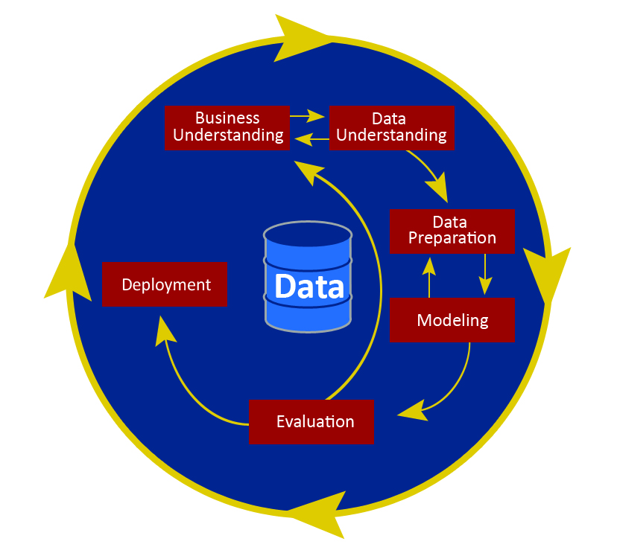

**Business Understanding**

The Business Understanding phase is focused on good problem definition and ensuring that you are solving the business's problem. You must begin from a business perspective and business knowledge, and proceed by converting this knowledge into a data mining problem definition. You will not be performing the actual Business Understanding in Modeler, as such, but Modeler allows you to organize supporting material such as word documents and PowerPoint presentations as part of a Modeler project file. You don't need to organize this material in a project file, but you do need to remember to do a proper job at this phase. For more detailed information on each task within a phase, refer to the CRISP-DM document itself. It is free and readily available on the internet.

The four tasks in this phase are:

* Determine business objectives
* Assess situation
* Determine data mining goals
* Produce project plan

**Data Understanding**

Modeler has numerous resources for exploring your data in preparation for the other phases. We will demonstrate a number of these in [**Chapter 3**](https://learning.oreilly.com/library/view/ibm-spss-modeler/9781788291118/ca021840-82af-4c8e-9b27-6ec106fe89d9.xhtml)**, Importing Data into Modeler**; [**Chapter 4**](https://learning.oreilly.com/library/view/ibm-spss-modeler/9781788291118/a6ec9a91-b13b-4837-9f1d-a02b32b4b3d3.xhtml)**, Data Quality and Exploration**; and [**Chapter 8**](https://learning.oreilly.com/library/view/ibm-spss-modeler/9781788291118/fd312311-eea5-4cd3-9868-26e31f930d3e.xhtml)**, Looking for Relationships Between Fields**. The Data Understanding phase includes activities for getting familiar with the data as well as data collection and data quality. The four Data Understanding tasks are:

* Collect initial data
* Describe data
* Explore data
* Verify data quality

# Data Preparation

The Data Preparation phase covers all activities to construct the final dataset (the data that will be fed into the modeling tool(s)) from the initial raw data. Data Preparation is often described as the most labor-intensive phase for the data analyst. It is terribly important that Data Preparation is done well, and a substantial amount of this book is dedicated to it. We cover cleaning, selecting, integrating, and constructing data, in [**Chapter 5**](https://learning.oreilly.com/library/view/ibm-spss-modeler/9781788291118/6266a543-e2e0-40df-9db7-56ae8716ea1e.xhtml)**, Cleaning and Selecting Data;**[**Chapter 6**](https://learning.oreilly.com/library/view/ibm-spss-modeler/9781788291118/388a6cc9-9510-42c2-851b-016d0b3694e5.xhtml)**, Combining Data Files; and**[**Chapter 7**](https://learning.oreilly.com/library/view/ibm-spss-modeler/9781788291118/82112016-e3ce-4f75-8b44-0737e0ecd512.xhtml)**, Deriving New Fields**, respectively. However, a book dedicated to the basics of data mining can really only start you on your journey when it comes to Data Preparation, since there are so many ways in which you can improve and prepare data. When you are ready for a more advanced treatment of this topic, there are two resources that will go into Data Preparation in much more depth, and both have extensive Modeler software examples: The IBM SPSS Modeler Cookbook (Packt Publishing) and Effective Data Preparation (Cambridge University Press).

The five Data Preparation tasks are:

* Select data
* Clean data
* Construct data
* Integrate data
* Format data

# Modeling

The Modeling phase is probably what you expect it to be—the phase where the modeling algorithms move to the forefront. In many ways, this is the easiest phase, as the algorithms do a lot of the work if you have done an excellent job on the prior phases and you've done a good job translating the business problem into a data mining problem. Despite the fact that the algorithms are doing the heavy lifting in this phase, it is generally considered the most intimidating; it is understandable why. There are an overwhelming number of algorithms to choose from. Even in a well-curated workbench such as Modeler, there are dozens of choices. Open source options such as R have hundreds of choices. While this book is not an algorithms guide, and even though it is impossible to offer a chapter on each algorithm, [**Chapter 9**](https://learning.oreilly.com/library/view/ibm-spss-modeler/9781788291118/0c9ca12c-c11b-45c7-bf79-7cfe68d72959.xhtml)**, Introduction to Modeling Options** in IBM SPSS Modeler should be very helpful in understanding, at a high level, what options are available in Modeler. Also, in [**Chapter 10**](https://learning.oreilly.com/library/view/ibm-spss-modeler/9781788291118/ae8c1d57-91ed-40b1-a330-f4bb858aafe2.xhtml)**, Decision Tree Models** we go through a thorough demonstration of one modeling technique, decision trees, to orient you to modeling in Modeler.

The four tasks in this phase are:

* Select modeling technique
* Generate test design
* Build model
* Assess model

# Evaluation

At this stage in the project you have built a model (or models) that appears to be of high quality, from a data analysis perspective. Before proceeding to final deployment of the model, it is important to more thoroughly evaluate the model—to be certain it properly achieves the business objectives.

Evaluation is frequently confused with model assessment—the last task of the Modeling phase. Assess model is all about the data analysis perspective and includes metrics such as model accuracy. The authors of CRISP-DM considered calling this phase business evaluation because it has to be conducted in the language of the business and using the metrics of the business as indicators of success. Given the nature of this book, and its emphasis on the point and click operation of Modeler, there will be virtually no opportunity to practice this phase, but in real world projects it is a critical phase.

The three tasks in this phase are:

* Evaluate results
* Review process
* Determine next steps

# Deployment

Creation of the model is generally not the end of the project. Depending on the requirements, the Deployment phase can be as simple as generating a report or as complex as implementing a repeatable data mining process. Given the software focus of this book and the spirit of sticking to the basics, we will really only cover using models for the scoring of new data. Real world deployment is much more complex and a complex deployment can more than double the length of a project. Modeler's capabilities in this area go far beyond what we will be able to show in this book. The final chapter of this book, [**Chapter 11**](https://learning.oreilly.com/library/view/ibm-spss-modeler/9781788291118/60be6f44-9160-45a2-a1b3-dece5411ea78.xhtml)**, Model Assessment and Scoring**, briefly talks about some of these issues.

However, it is not unusual for the deployment team to be different than the modeling team, and the responsibility may fall to team members with more of an IT focus. The IBM software stack offers dedicated tools for complex deployment scenarios. IBM Collaboration and Deployment Services has such advanced features.

The four tasks in the Deployment phase are:

* Plan deployment
* Plan monitoring and maintenance
* Produce final report
* Review project

**The data mining process (as a case study)**

As [**Chapter 9**](https://learning.oreilly.com/library/view/ibm-spss-modeler/9781788291118/0c9ca12c-c11b-45c7-bf79-7cfe68d72959.xhtml)**, Introduction to Modeling Options** in IBM SPSS Modeler will illustrate, there are many different types of data mining projects. For example, you may wish to create customer segments based on products purchased or service usage, so that you can develop targeted advertising campaigns. Or you may want to determine where to better position products in your store, based on customer purchase patterns. Or you may want to predict which students will drop out of school, so that you can provide additional services before this happens.

In this book, we will be using a dataset where we are trying to predict which people have incomes above or below $50,000. We may be trying to do this because we know that people with incomes above $50,000 are much more likely to purchase our products, given that previous work found that income was the most important predictor regarding product purchase. The point is that regardless of the actual data that we are using, the principles that we will be showing apply to an infinite number of data mining problems; whether you are trying to determine which customers will purchase a product, or when you will need to replace an elevator, or how many hotels rooms will be booked on a given date, or what additional complications might occur during surgery, and so on.

As was mentioned previously, Modeler supports the entire data mining process. The figure shown next illustrates exactly how Modeler can be used to compartmentalize each aspect of the CRISP-DM process model:

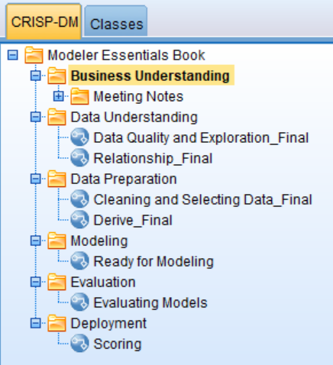

In [**Chapter 2**](https://learning.oreilly.com/library/view/ibm-spss-modeler/9781788291118/ca1bd3d2-2ffb-4863-a7ce-0463b2a21d7c.xhtml)**, The Basics of Using IBM SPSS Modeler**, you will become familiar with the Modeler graphic user interface. In this chapter, we will be using screenshots to illustrate how Modeler represents various data mining activities. Therefore the following figures in this chapter are just providing an overview of how different tasks will look within Modeler, so for the moment do not worry about how each image was created, since you will see exactly how to create each of these in later chapters.

First and foremost, every data mining project will need to begin with well-defined business objectives. This is crucial for determining what you are trying to accomplish or learn from a project, and how to translate this into data mining goals. Once this is done, you will need to assess the current business situation and develop a project plan that is reasonable given the data and time constraints.

Once business and data mining objectives are well defined, you will need to collect the appropriate data. [**Chapter 3**](https://learning.oreilly.com/library/view/ibm-spss-modeler/9781788291118/ca021840-82af-4c8e-9b27-6ec106fe89d9.xhtml)**, Importing Data into Modeler** will focus on how to bring data into Modeler. Remember that data mining typically uses data that was collected during the normal course of doing business, therefore it is going to be crucial that the data you are using can really address the business and data mining goals:

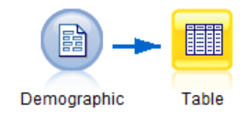

Once you have data, it is very important to describe and assess its quality. [**Chapter 4**](https://learning.oreilly.com/library/view/ibm-spss-modeler/9781788291118/a6ec9a91-b13b-4837-9f1d-a02b32b4b3d3.xhtml)**, Data Quality and Exploration** will focus on how to assess data quality using the Data Audit node:

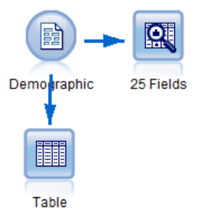

Once the Data Understanding phase has been completed, it is time to move on to the Data Preparation phase. The Data Preparation phase is by far the most time consuming and creative part of a data mining project. This is because, as was mentioned previously, we are using data that was collected during the normal course of doing business, therefore the data will not be clean, it will have errors, it will include information that is not relevant, it will have to be restructured into an appropriate format, and you will need to create many new variables that extract important information. Thus, due to the importance of this phase, we have devoted several chapters to addressing these issues**.**[**Chapter 5**](https://learning.oreilly.com/library/view/ibm-spss-modeler/9781788291118/6266a543-e2e0-40df-9db7-56ae8716ea1e.xhtml)**, Cleaning and Selecting Data**will focus on how to select the appropriate cases, by using the Select node, and how to clean data by using the Distinct and Reclassify nodes:

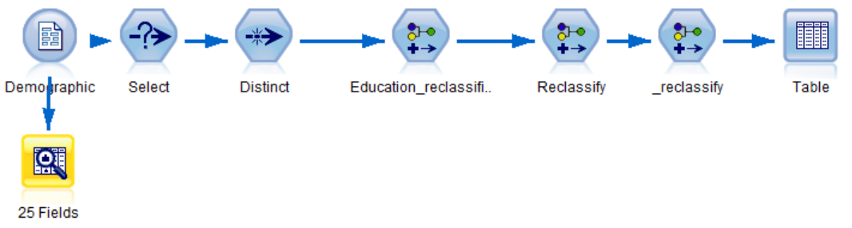

[**Chapter 6**](https://learning.oreilly.com/library/view/ibm-spss-modeler/9781788291118/388a6cc9-9510-42c2-851b-016d0b3694e5.xhtml)**, Combining Data Files** will continue to focus on the Data Preparation phase by using both the Append and Merge nodes to integrate various data files:

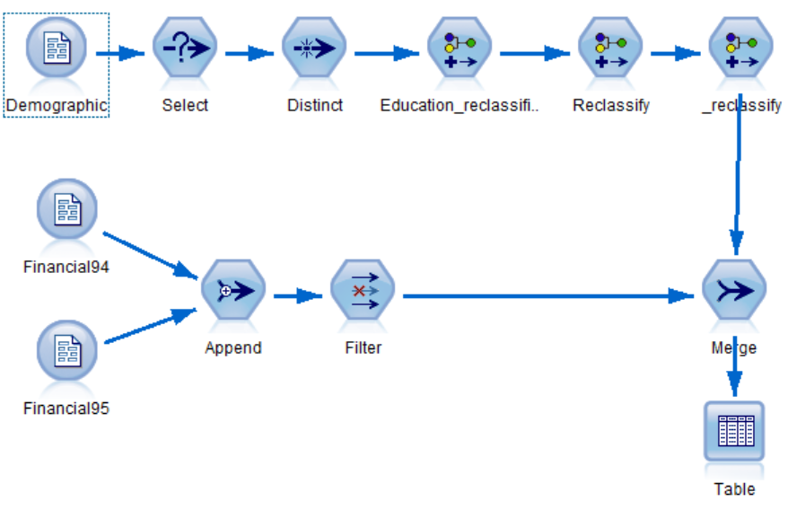Finally, [**Chapter 7**](https://learning.oreilly.com/library/view/ibm-spss-modeler/9781788291118/82112016-e3ce-4f75-8b44-0737e0ecd512.xhtml)**, Deriving New Fields** will focus on constructing additional fields by using the Derive node:

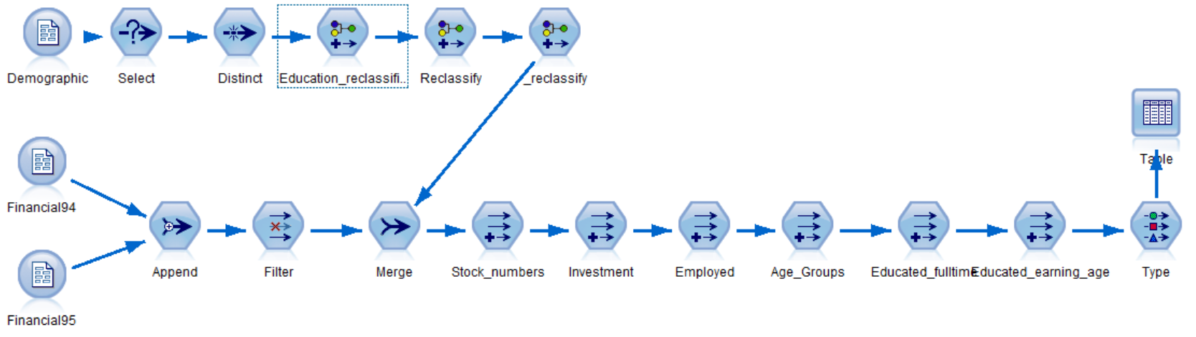

At this point we will be ready to begin exploring relationships within the data. **In**[**Chapter 8**](https://learning.oreilly.com/library/view/ibm-spss-modeler/9781788291118/fd312311-eea5-4cd3-9868-26e31f930d3e.xhtml)**, Looking for Relationships Between Fields** we will use the Distribution, Matrix, Histogram, Means, Plot, and Statistics nodes to uncover and understand simple relationships between variables:

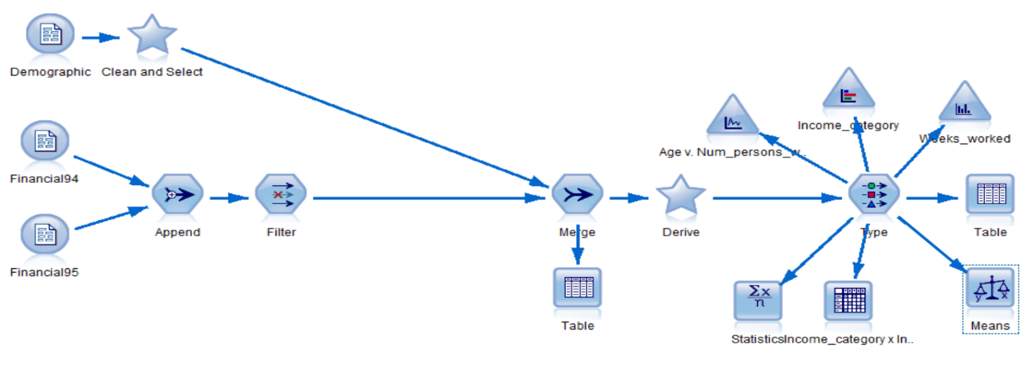

Once the Data Preparation phase has been completed, we will move on to the Modeling phase. [**Chapter 9**](https://learning.oreilly.com/library/view/ibm-spss-modeler/9781788291118/0c9ca12c-c11b-45c7-bf79-7cfe68d72959.xhtml)**, Introduction to Modeling Options in IBM SPSS** Modeler will introduce the various types of models available in Modeler and then provide an overview of the predictive models. It will also discuss how to select a modeling technique**.**[**Chapter 10**](https://learning.oreilly.com/library/view/ibm-spss-modeler/9781788291118/ae8c1d57-91ed-40b1-a330-f4bb858aafe2.xhtml)**, Decision Tree Models** will cover the theory behind decision tree models and focus specifically on how to build a CHAID model. We will also use a Partition node to generate a test design; this is extremely important because only through replication can we determine whether we have a verifiable pattern:

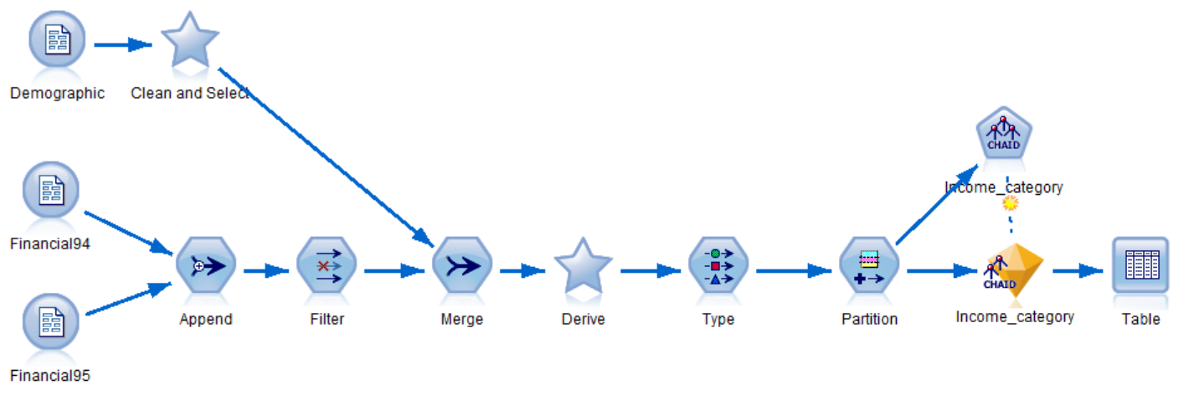

[**Chapter 11**](https://learning.oreilly.com/library/view/ibm-spss-modeler/9781788291118/60be6f44-9160-45a2-a1b3-dece5411ea78.xhtml)**, Model Assessment and Scoring** is the final chapter in this book and it will provide readers with the opportunity to assess and compare models using the Analysis node. The Evaluation node will also be introduced as a way to evaluate model results:

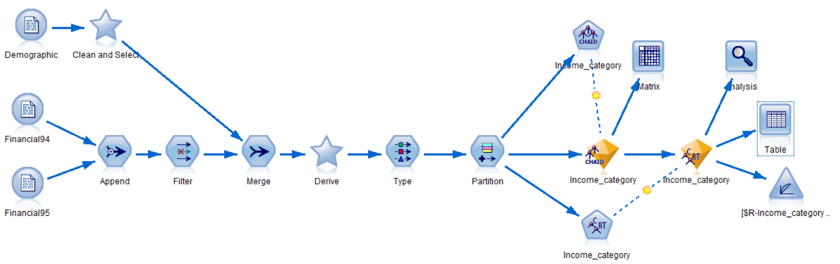

Finally, we will spend some time discussing how to score new data and export those results to another application using the Flat File node:

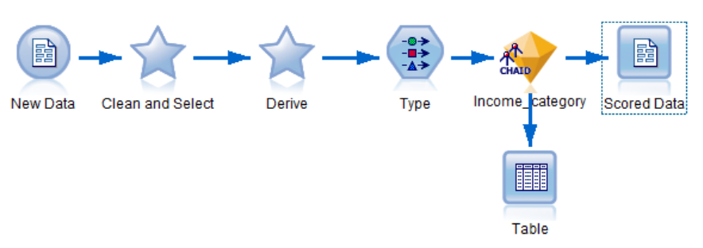

# Summary

In this chapter, you were introduced to the notion of data mining and the CRISP-DM process model. You were also provided with an overview of the data mining process, along with previews of what to expect in the upcoming chapters.

In the next chapter you will learn about the different components of the Modeler graphic user interface. You also learn how to build streams. Finally, you will be introduced to various help options.

# Chapter 2 - The Basics of Using IBM SPSS Modeler

The previous chapter introduced the notion of data mining and the CRISP-DM process model. You learned what data mining is, why you would want to use it, and some of the types of questions you could answer with data mining. The rest of this book is going to focus on how you actually do some of the aspects of data mining—reading data, exploring variables, deriving new fields, developing models, and so on. However, before we can get started with these different data mining projects, we first need to become familiar with the software that we will use to work on the data. In this chapter, you will learn the following:

* Get an overview of the Modeler interface
* Learn how to build streams
* Get an introduction to various help options

**Introducing the Modeler graphic user interface**

IBM SPSS Modeler can be thought of as a data mining workbench that combines multiple tools and technologies to support the data mining process. Modeler allows users to mine data visually on the stream canvas.

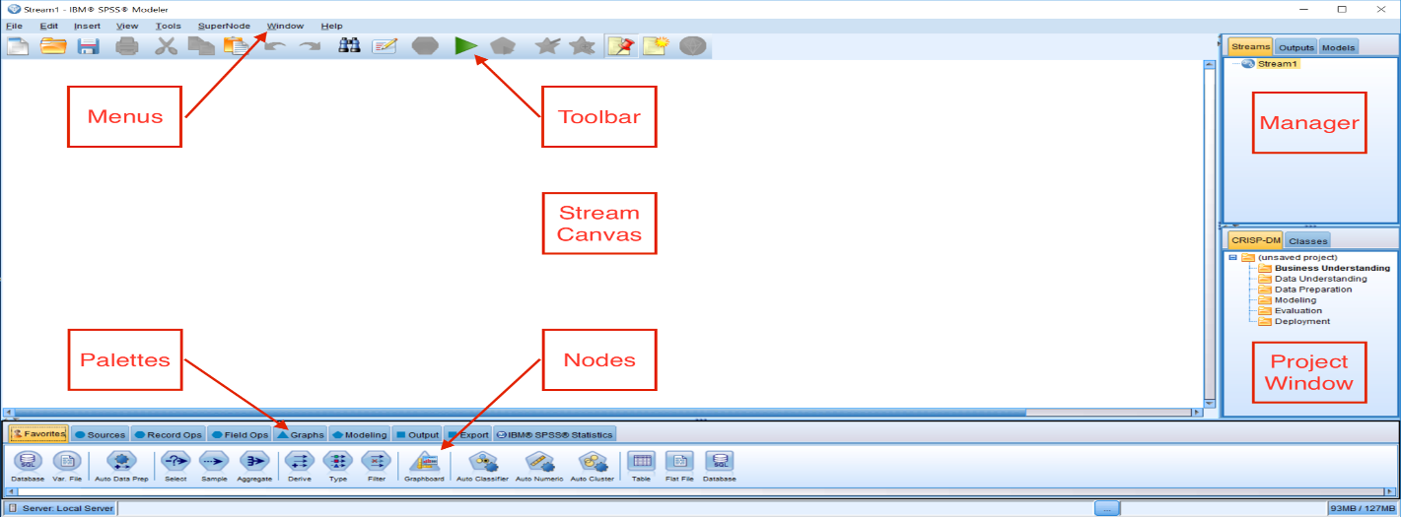

As you can see, the Modeler interface is comprised of several components, and these are described in the next few pages.

# Stream canvas

The stream canvas is the main work area in Modeler. It is located in the center of the Modeler user interface. The stream canvas can be thought of as a surface on which to place icons or nodes. These nodes represent operations to be carried out on the data. Once nodes have been placed on the stream canvas, they can be linked together to form a stream

# Palettes

Nodes (operations on the data) are contained in palettes. The palettes are located at the bottom of the Modeler user interface. Each palette contains a group of related nodes that are available for you to add to the data stream. For example, the Sources palette contains nodes that you can use to read data into Modeler, and the Graphs palette contains nodes that you can use to explore your data visually. The icons that are shown depend on the active, selected palette.

The following is a brief description of each palette's functionality:

* The Favorites palette contains commonly used nodes. You can customize which nodes appear in this palette, as well as their order—for that matter, you can customize any palette.
* Sources nodes are used to access data.
* Record Ops nodes manipulate rows (cases).
* Field Ops nodes manipulate columns (variables).
* Graphs nodes are used for data visualization.
* Modeling nodes contain dozens of data mining algorithms.
* Output nodes present data to the screen.
* Export nodes write data to a data file.
* IBM SPSS Statistics nodes can be used in conjunction with IBM SPSS Statistics.

# Modeler menus

In the upper left-hand section of the Modeler user interface, there are eight menus. The menus control a variety of options within Modeler, as follows:

* File allows users to create, open, and save Modeler streams and projects. Streams can also be printed from this menu.
* Edit allows users to perform editing operations, for example, copying/pasting objects, clearing manager tabs, and editing individual nodes.
* Insert allows users to insert a particular node as an alternative to dragging a node from a palette.
* View allows users to toggle between hiding and displaying items (for example, the toolbar or the Project window).
* Tools allows users to manipulate the environment in which Modeler works and provides facilities for working with scripts.
* SuperNode allows users to create, edit, and save a condensed stream.
* Window allows users to close related windows (for example, all open output windows), or switch between open windows.
* Help allows users to access help on a variety of topics or to view a tutorial.

# Toolbar

The icons on the toolbar represent commonly used options that can also be accessed via the menus, however the toolbar allows users to enable these options via this easy-to-use, one-click alternative:

The options on the toolbar include:

* Creating a new stream
* Opening an existing stream
* Saving the current stream
* Printing the current stream
* Moving a selection to the clipboard
* Copying a selection to the clipboard
* Pasting a selection to the clipboard
* Undoing the last action
* Redoing the last action
* Searching for nodes in the current stream
* Editing the properties of the current stream
* Previewing the running of a stream
* Running the current stream
* Running a selection
* Encapsulating selected nodes into a supernode
* Zooming in on a supernode
* Showing/hiding stream markup
* Inserting a new comment
* Opening IBM SPSS Modeler Advantage

# Manager tabs

In the upper right-hand corner of the Modeler user interface, there are three types of manager tabs. Each tab (Streams, Outputs, and Models) is used to view and manage the corresponding type of object, as follows:

* The Streams tab opens, renames, saves, and deletes streams created in a session.
* The Outputs tab stores Modeler output, such as graphs and tables. You can save output objects directly from this manager.
* The Models tab contains the results of the models created in Modeler. These models can be browsed directly from the Models tab or on the stream displayed on the canvas.

# Project window

In the lower right-hand corner of the Modeler user interface, there is the project window. This window offers two ways to organize your data mining work, including:

* The CRISP-DM tab, which organizes streams, output, and annotations according to the phases of the CRISP-DM process model
* The Classes tab, which organizes your work in Modeler by the type of objects created

**Building streams**

As was mentioned previously, Modeler allows users to mine data visually on the stream canvas. This means that you will not be writing code for your data mining projects; instead you will be placing nodes on the stream canvas. Remember that nodes represent operations to be carried out on the data. So once nodes have been placed on the stream canvas, they need to be linked together to form a stream. A stream represents the flow of data going through a number of operations (nodes). The following diagram is an example of nodes on the canvas, as well as a stream:

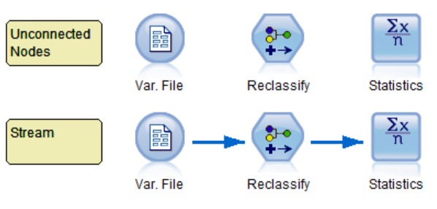

Given that you will spend a lot of time building streams, in this section you will learn the most efficient ways of manipulating nodes to create a stream.

# Mouse buttons

When building streams, mouse buttons are used extensively so that nodes can be brought onto the canvas, connected, edited, and so on. When building streams within Modeler, mouse buttons are used in the following ways:

* The left button is used for selecting, placing, and positioning nodes on the stream canvas
* The right button is used for invoking context (pop-up) menus that allow for editing, connecting, renaming, deleting, and running nodes
* The middle button (optional) is used for connecting and disconnecting nodes

# Adding nodes

To begin a new stream, a node from the Sources palette needs to be placed on the stream canvas. There are three ways to add nodes to a stream from a palette:

**Method one**: Click on palette and then on stream:

1. Click on the Sources palette.
2. Click on the Var. File node.

This will cause the icon to be highlighted.

3. Move the cursor over the stream canvas.

4.Click anywhere in the stream canvas.

A copy of the selected node now appears on the stream canvas. This node represents the action of reading data into Modeler from a delimited text data file. If you wish to move the node within the stream canvas, select it by clicking on the node, and while holding the left mouse button down, drag the node to a new position.

**Method two**: Drag and drop:

1. Now go back to the Sources palette.
2. Click on the Statistics File node and drag and drop this node onto the canvas.

The Statistics File node represents the action of reading data into Modeler from an IBM SPSS Statistics data file.

**Method three**: Double-click:

1. Go back to the Sources palette one more time.
2. Double click on the Database node.

The Database node represents the action of reading data into Modeler from an ODBC compliant database.

# Editing nodes

Once a node has been brought onto the stream canvas, typically at this point you will want to edit the node so that you can specify which fields, cases, or files you want the node to apply to. There are two ways to edit a node.

**Method one**: Right-click on a node:

1. Right-click on the Var. File node:

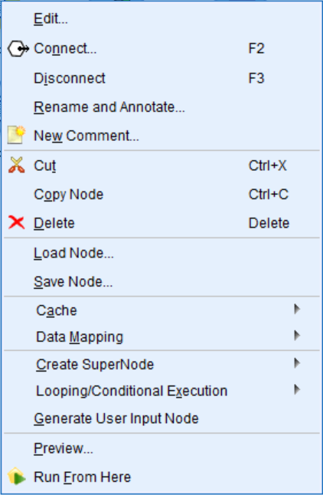

Notice that there are many things you can do within this context menu. You can edit, add comments, copy, delete a node, connect nodes, and so on. Most often you will probably either edit the node or connect nodes.

**Method two**: Double-click on a node:

1. Double-click on the Var. File node.

This bypasses the context menu we saw previously, and goes directly into the node itself so we can edit it.

# Deleting nodes

There will be times when you will want to delete a node that you have on the stream canvas. There are two ways to delete a node.

**Method one**: Right-click on a node:

1. Right-click on the Database File node.
2. Select Delete.

The node is now deleted.

**Method two**: Use the Delete button from the keyboard:

1. Click on the Statistics File node.
2. Click on the Delete button on the keyboard.

# Building a stream

When two or more nodes have been placed on the stream canvas, they need to be connected to produce a stream. This can be thought of as representing the flow of data through the nodes.

To demonstrate this, we will place a Table node on the stream canvas next to the Var. File node. The Table node presents data in a table format.

1. Click the Output palette to activate it.
2. Click on the Table node.

Place this node to the right of the Var. File node by clicking in the stream canvas:

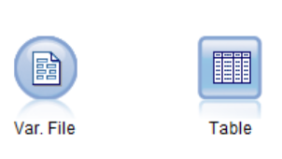

At this point, we now have two nodes on the stream canvas, however, we technically do not have a stream because the nodes are not speaking to each other (that is, they are not connected).

# Connecting nodes

In order for nodes to work together, they must be connected. Connecting nodes allows you to bring data into Modeler, explore the data, manipulate the data (to either clean it up or create additional fields), build a model, evaluate the model, and ultimately score the data. There are three main ways to connect nodes to form a stream that is, double-clicking, using the middle mouse button, or manually:

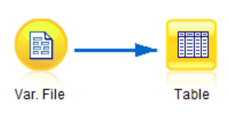

**Method one**: Double-click.

The simplest way to form a stream is to double-click on nodes on a palette. This method automatically connects the new node to the currently selected node on the stream canvas:

1. Select the Var. File node that is on the stream canvas.
2. Double-click the Table node from the Output palette.

This action automatically connects the Table node to the existing Var. File node, and a connecting arrow appears between the nodes. The head of the arrow indicates the direction of the data flow.

**Method two**: Manually.

To manually connect two nodes:

1. Bring a Table node onto the canvas.
2. Right-click on the Var. File node.
3. Select Connect from the context menu.
4. Click the Table node.

**Method three**: Middle mouse button.

To use the middle mouse button:

1. Bring a Table node onto the canvas.
2. Use the middle mouse button to click on the Var. File node.
3. While holding the middle mouse button down, drag the cursor over to the Table node.
4. Release the middle mouse button.

# Deleting connections

When you know that you are no longer going to use a node, you can delete it. Often, though, you may not want to delete a node; instead you might want to delete a connection. Deleting a node completely gets rid of the node. Deleting a connection allows you to keep a node with all the edits you have done, but for now the unconnected node will not be part of the stream. Nodes can be disconnected in several ways:

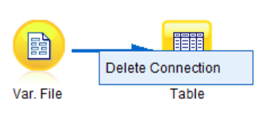

**Method one**: Delete the connecting arrow:

1. Right-click on the connecting arrow.
2. Click Delete Connection.

**Method two**: Right-click on a node:

1. Right-click on one of the nodes that has a connection.
2. Select Disconnect from the Context menu.

**Method three**: Double-clicking:

1. Double-click with the middle mouse button on a node that has a connection.

All connections to this node will be severed, but the connections to neighboring nodes will be intact.

# Modeler stream rules

You may have noticed that in the previous example, we connected the Var. File node to the Table node and this worked fine. However, what if instead we tried to connect the Table node to the Var. File node? Let's try it:

1. Right-click the Table node.
2. Select Connect from the Context menu (notice that the Connect option does not exist).

Let's try something different:

1. Bring a Statistics File node onto the canvas.
2. Right-click on the Var. File node.
3. Select Connect from the Context menu.
4. Click the Statistics File node (notice that you get an error message when you try to connect these two nodes).

The reason we are experiencing these issues is that there are rules for creating Modeler streams.

Modeler streams are typically comprised of three types of nodes: Source, Process, and Terminal nodes. Connecting nodes in certain ways makes sense in the context of Modeler, and other connections are not allowed.

In terms of general rules, streams always start with a Source node (a node from the Sources palette), since these nodes import data. Source nodes can only have arrows directed out of them, but not into them. The Var. File node is an example of a Source node. This is why we can connect the Var. File node to a Table node, but we cannot connect the Statistics file node to the Var. File node. As a visual reminder, Source nodes are circular.

Process nodes are data preparation nodes, and they come from the Record Ops and Field Ops palettes. These nodes are hexagonal in shape and they can have arrows directed into or out of them. Technically, Process nodes are optional (every stream requires Source and Terminal nodes), however in reality, quite often Process nodes are the most commonly used nodes in a stream. For example, the Derive node is a process node. To see an example of how to add a process node to a stream, do the following:

1. Right-click on the Var. File node.
2. Select Connect from the Context menu.
3. Click the Table node.
4. Click the Field Ops palette to activate it.
5. Click on the Derive node.
6. Place this node in-between the Var. File node and the Table node by clicking in the stream canvas.
7. Click on the arrow connecting the Var. File node and the Table node and drag and drop the connection onto the Derive node, as shown in the following diagram:

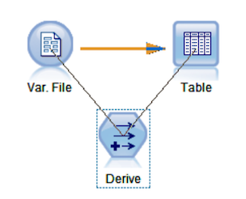

All three nodes are now connected and the Derive node has an arrow directed into and out of it.

Every stream always ends with a Terminal node. These nodes appear at the end of a stream and they can only have arrows directed into them, but not out of them. The Table node is an example of a Terminal node. This is why we can connect the Var. File node to a Table node, but we cannot connect the Table node to the Var. File node. Terminal nodes are found in the Graphs (triangle), Modeling (pentagon), Output (square), and Export(square) palettes.

# Dialog help

Perhaps the most useful help option is to use context sensitive help, which is available in whatever dialog box you are currently working on. For example, let's say that you are using the Var. File node and you either did not know how to use this node or you were unfamiliar with some of the options. First, let's open this node:

1. Right-click on the Var. File node.
2. Click Edit.
3. Now, to get help, click on the Help button (the icon with a question mark):

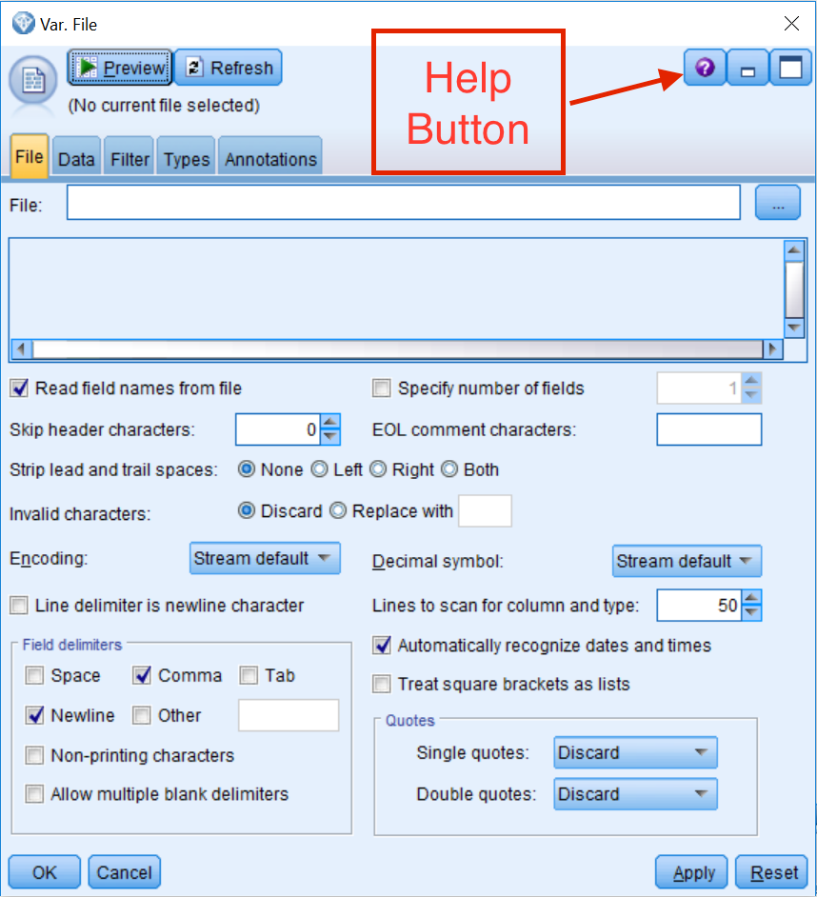

Notice that a new window explaining the different options within the Var. File source node appears, which provides specific information about the options in this dialog box:

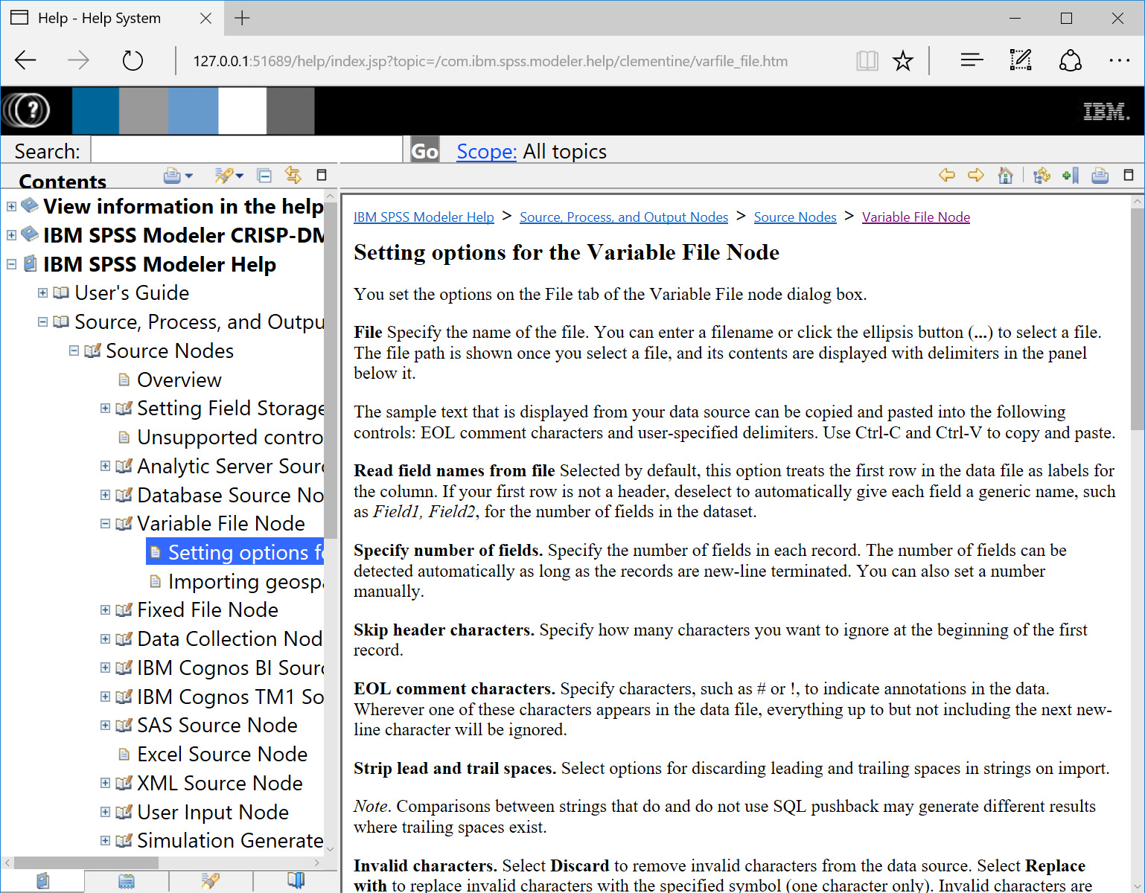

In this way, you can become familiar with this node and its options.

You can close this window and return to the stream canvas.

# Summary

In this chapter, you learned about the different components of the Modeler graphic user interface. You also learned how to build streams. Finally, you were introduced to various help options.

In the next chapter, we will take a detailed look at how to bring data into Modeler. We will also discuss how to properly set up the metadata for your fields.

# Chapter -3 Importing Data into Modeler

The previous chapter introduced the Modeler graphic user interface. You learned where different components of the program are located, how to work with nodes and create streams, and how to use various help options. Being somewhat familiar now with the software, we are ready to get started on our data mining project. The first step is to bring data into Modeler. In this chapter, you will:

* Get an overview of the general data structure that is used in Modeler
* Learn how to read and display data in Modeler
* Get an introduction to level of measurement and field roles

**Data structure**

Modeler can read data from a variety of different file formats. If you take a look at the Sources palette, you will see that Modeler can read data from any one of the data import nodes: text files, databases, IBM SPSS Statistics or Cognos, SAS, or Excel, in addition to many others. In fact, unlike programs such as Microsoft Excel or IBM SPSS Statistics, where you can manually enter data into the program, in Modeler you must read data into the software from an external file. In this chapter, the focus will be on reading data files from free-field text files, which is a common file type. We will also briefly show you the options for reading in data from two other commonly used sources, Microsoft Excel and ODBC databases.

The following figure depicts the typical data structure used in Modeler. In general, Modeler uses a data structure in which the rows of a table represent cases and the columns of a table represent variables. In this figure, we can see that each row represents a person and each column represents a demographic characteristic of that individual. For example, in the first row we have the data for the person with the label ID 1001. We can see that this person is 73 years old, is a High school graduate, and so on:

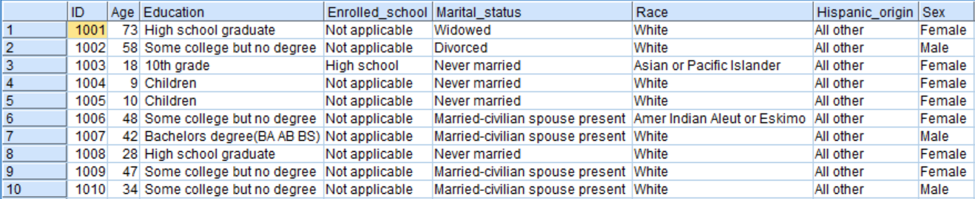

When data is in this format, it is very important that each row in a file has the same unit of analysis. For example, in a file where each record or row of data represents a unique employee, then the employee is the unit of analysis. In another file, each row may represent a department; in this case the department is the unit of analysis. If a project requirement is to merge these two files, you might need to aggregate the employee information so that each row represents the department.

# Var. File source node

The Var. File source node reads data from a delimited (free-field) text file. In the following example, we will read a comma-delimited data file with field names in the first row. The file contains demographic information such as Age, Education, Marital_status, and so on. We will read this file into Modeler using the Var. File source node.

If the stream canvas is not empty, clear the stream canvas by doing the following:

1. Click the Edit menu, then select Clear stream.
2. Select the Sources palette.
3. Double-click on the Var. File node (this node should now be on the canvas).

The Var. File source node represents the process of reading a delimited text data file into Modeler. To link this node to a specific data file, you will need to edit the node:

1. Right-click on the Var. File node.
2. Click Edit (alternatively, double-click on the Var. File node).

# Var. File source node File tab

The File tab in a source node points to the exact location of the data file you are trying to link up to the node. This tab also allows users to specify information needed to correctly bring the data into Modeler. The first thing to do in the File tab is to specify the data file's name and location:

1. Click on the file list button (...), marked with three dots, in the upper right-hand corner of the menu.
2. Navigate to where the data file is located and select the file Demographic.txt.
3. Click Open:

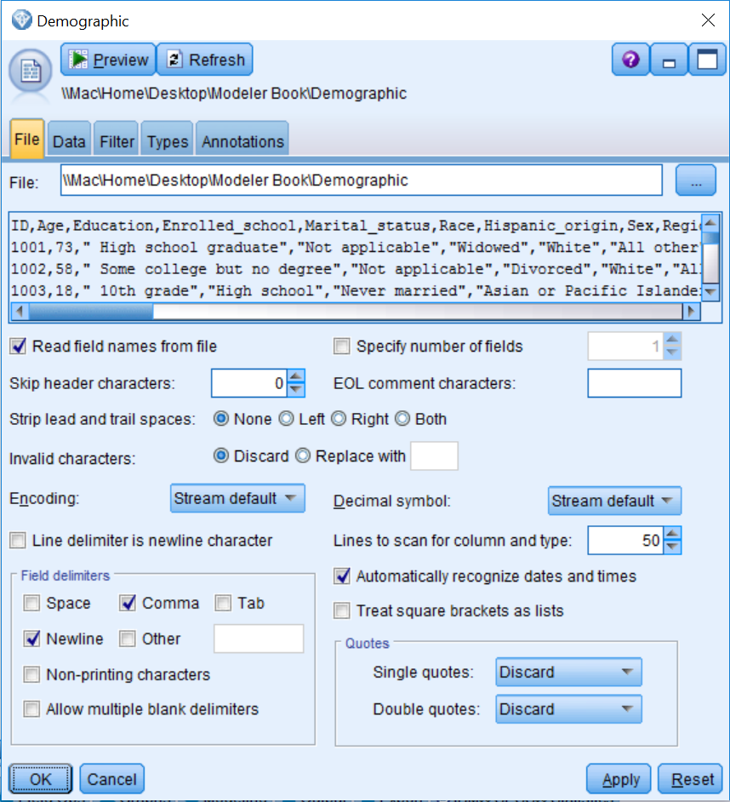

The Var. File dialog provides a preview of the first few lines of the data. Notice that the first line contains the field names and the data begins on the second line. This is the ideal scenario for a text file, because now Modeler can read the field names directly. Just make sure the Read field names from file check box is selected. By default, this option is already selected, however if the field names are not located in the first line of the file, deselect this option so that generic names, such as field 1, field 2, and so on, can be given to the fields in the dataset.

Also notice that in the preview a comma separates each field. In this example, we have a file that matches the default (Comma) option in the Field delimiters section, however this will not always be the case, so it is important that the correct delimiter(s) are selected to separate the individual fields.

Most of the default options work well in the majority of situations, however on occasion you might find that the data is not read correctly. In our experience, one of the first options to modify is Strip lead and trail spaces. This option removes leading and trailing blanks (extra spaces) from string fields and will often fix problems. As you can see, there are many other options in this dialog, and descriptions of these options are presented in the following list:

* **Specify number of fields** allows you to specify how many fields are in each record in the data file if all fields for a data record are not contained on a single line. If all fields for a data record are contained on a single line, then the number of fields is left unspecified and Modeler automatically calculates the number of fields.
* **Skip header characters** allows you to specify how many characters are to be read and ignored before the first record begins.
* **EOL comment characters** specifies one or more characters that denote the start of a comment or annotation. When Modeler comes across these characters in the file, it will ignore what follows until a new line is started.
* **Invalid characters** allows users to either remove or replace any character not recognized in the encoding of your operating system.
* **Encoding** refers to the text encoding method used to represent the text.
* **Decimal symbol** allows users to set either a comma or a period by using the drop-down menu.
* **Lines to scan for column and type** scans 50 rows of data (by default) to determine a field's measurement level. The measurement level is a very important concept in Modeler and this will be discussed in more detail later on in this chapter.
* **Treat square brackets as lists** treats data included between opening and closing square brackets as a single value, even if the content includes delimiter characters such as commas and double quotes.
* Single and double quotes are dealt with using drop-down menus and can either be discarded (Discard), matched in pairs and then discarded (Pair & Discard), or included as text within the field (Include as text).

To view the additional functionality, let's click on the Data tab.

# Var. File source node Data tab

The Data tab controls the way each field is stored in Modeler, which in turn has implications for how a field can be used. Generally, the measurement level determined by Modeler is appropriate, however if you need to change this for a field, check the field's Override box, then click in its Storage cell and select the appropriate storage option.

In this example, we do not need to change anything on this tab. In our own experience, often you might need to specify the appropriate format for date and time fields here:

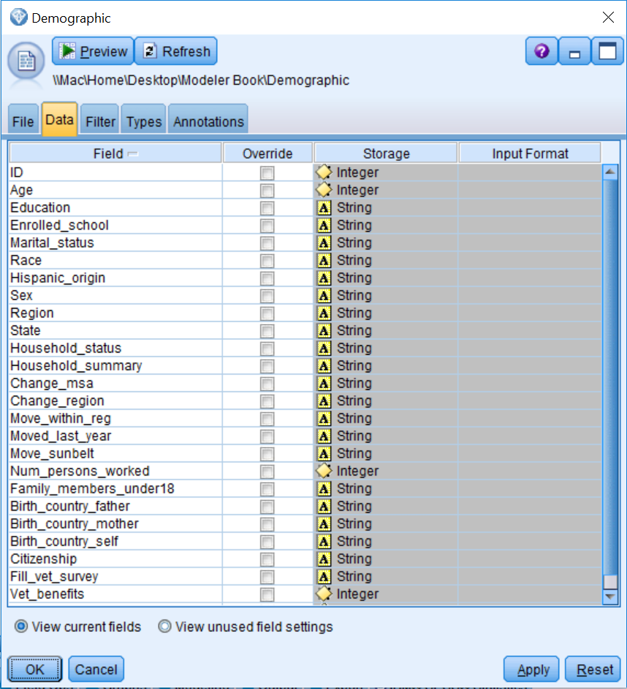

As an aside, the Data tab of most source nodes functions more like the File tab of the Var. File node. Thus, this design of the Data tab in the Var. File source node makes it very easy to change the format of fields that you would otherwise need to change using a Filler node.

Let's click on the Filter tab to see the additional options.

# Var. File source node Filter tab

The Filter tab allows users to remove and rename fields. The left Field column contains the field names as read from the data file. The Field column on the right contains the field names as they will leave this node, therefore this is where you can rename fields. The middle column shows an arrow that can be interpreted as *becomes*, and clicking on this arrow prevents fields from appearing downstream:

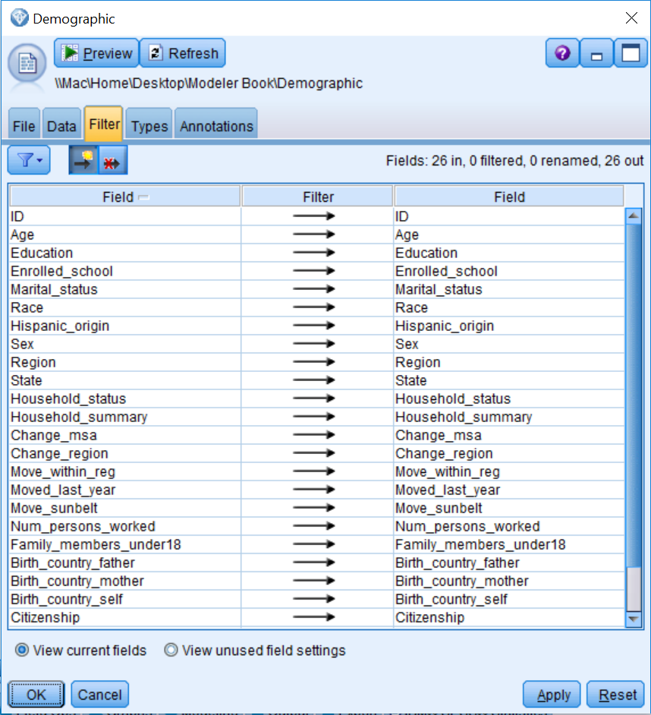

As an example, let's make a couple of changes:

1. Double-click on ID in the right Field column.
2. Change ID to ID_Number.
3. Click once on the arrow in the Age row:

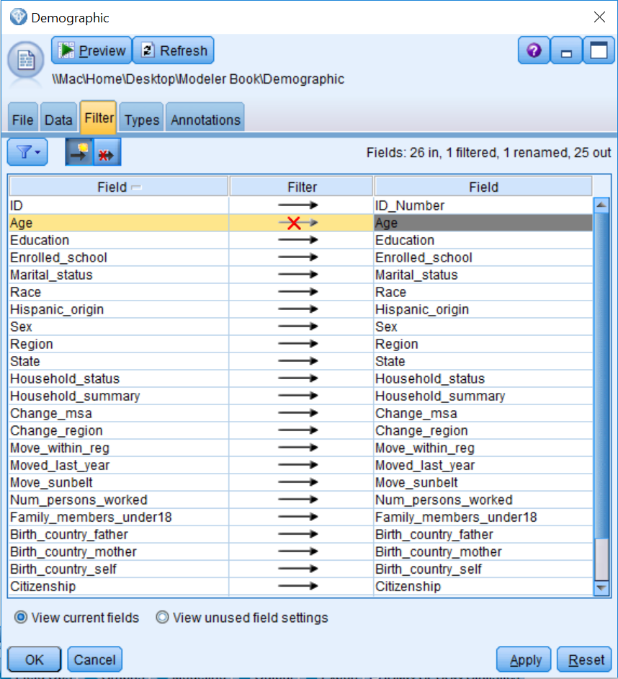

The field ID is renamed to ID_Number. The red cross on the arrow for the field Age indicates that data for the field Age will not be read downstream from this node. In fact, in the upper right-hand corner of the Filter tab, you can keep track of any changes that have been made. Here we can see that there are 26 fields in the original file; one of these fields has been filtered, one field has been renamed, and 25 fields will be shown downstream from this node.

Within the Filter tab, you can change the order of the fields (just click on the Field column header), exclude all fields at once, or include all fields at once. Furthermore, the Filter menu gives you access to numerous filter options such as including/excluding all fields, toggling between fields, removing or renaming duplicate field names, and truncating field names.

As an example, we will undo the previous changes:

1. Click the filter options button and select Include All Fields.
2. Click the filter options button and select Use Input Field Names.

The window should be the same as it was prior to changing the field ID into ID_Number and excluding the Age.

Let's briefly take a look at the Types tab.

# Var. File source node Types tab

The Types tab is the most important tab within any source node. It allows users to specify field metadata and properties, and will ultimately determine how each field is used within Modeler. Because the Types tab is so important, we will come back to the options for the Types tab in the level of measurement and roles section of this chapter.

Finally, let's look at the options on the Annotations tab.

**Var. File source node Annotations tab**

The Annotations tab allows users to create custom names for nodes and add notes or keywords. Specifying appropriate names or tooltip texts can be especially useful when trying to distinguish several of the same kinds of nodes on the canvas, or when using a script:

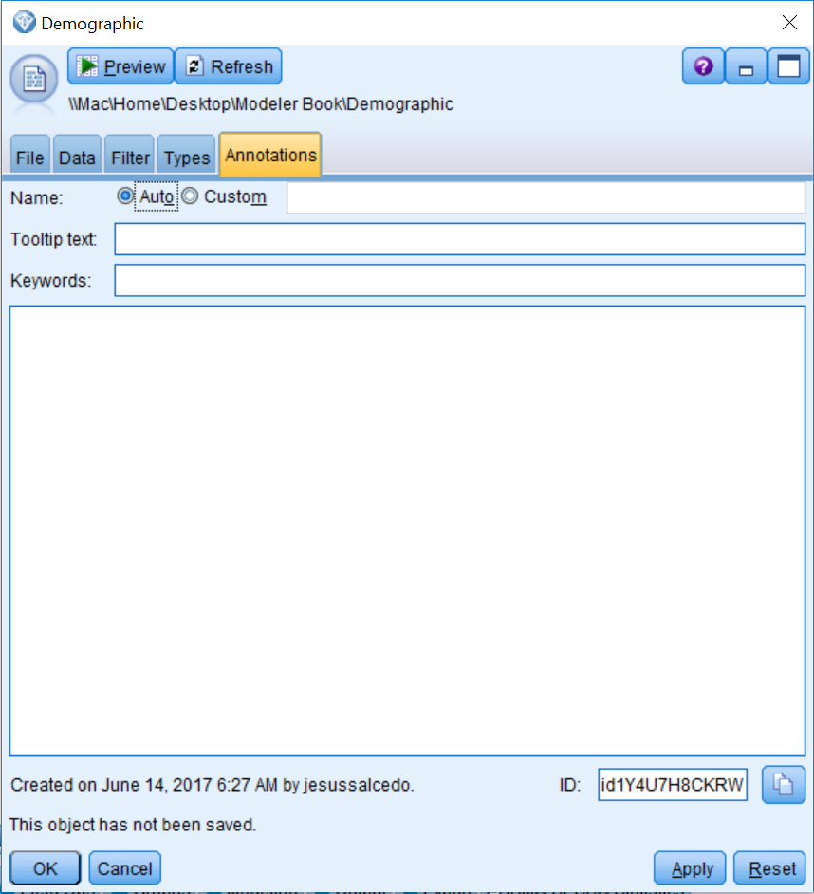

# Viewing data

It is important to always take a look at your data to make sure it is read correctly. The Table node displays the data in tabular form, with one row per record, and field names heading the columns. Let's take a look at our data:

1. Click on the Output palette.
2. Double-click on the Table node so that it is connected to the Var. File source node (which now has the name Demographic, since source nodes change their names to whatever a data file is called).

Now we need to run the table so that you can see the actual data:

1. Right-click on the Table node.
2. Select Run from the context menu.

The title bar of the Table displays the number of fields and records read into the table. Notice that we have 26 fields and 199,526 records:

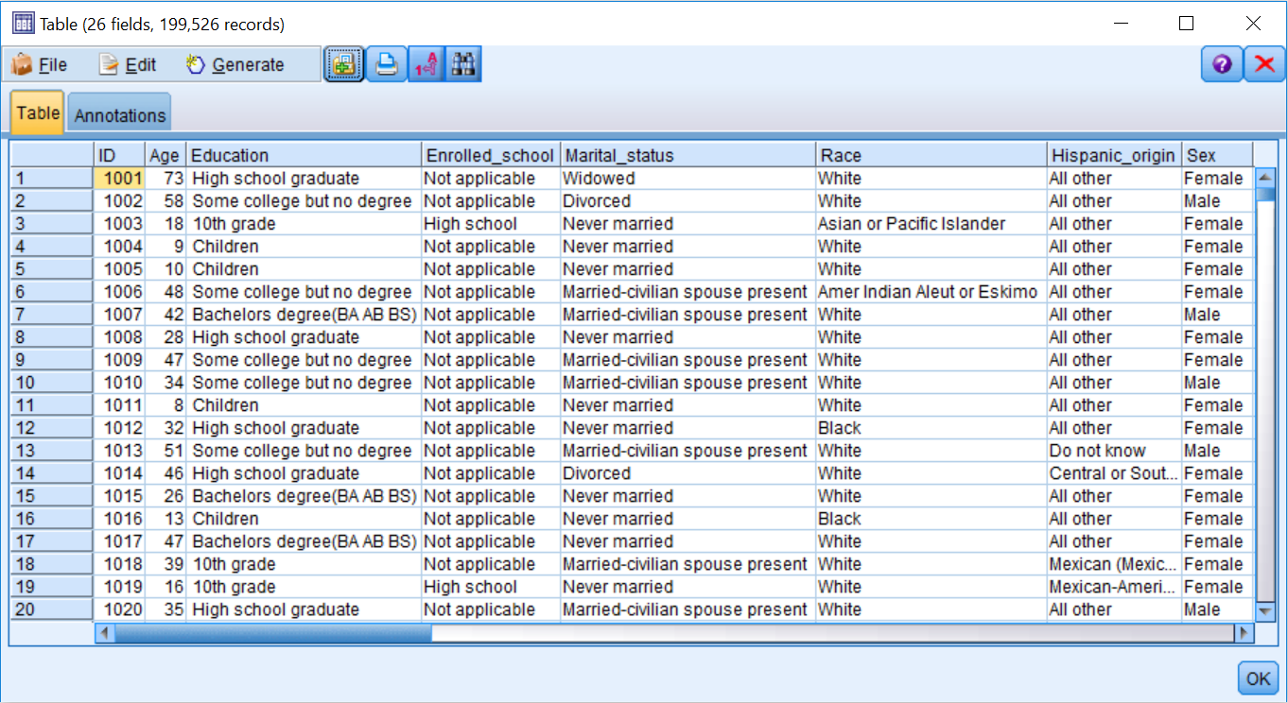

Take some time to look over the data.

The File menu in the Table window allows you to save, print, export, or publish the table. The Edit menu allows you to copy values or fields. The Generate menu allows you to automatically generate Select (data selection) or Derive (field calculation) nodes.

Now that we have done a brief check of the data file, we will close the window and return to the stream canvas, click OK.

Although we have closed the table, the table is still available in the Outputs tab. This means that we do not have to rerun the table again to see the data, which can be a big time saver if you have large data files.

To activate the outputs manager, click the Outputs tab:

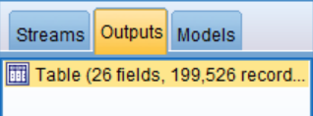

The table is still available from the manager. In fact, each output produced (table or chart) will automatically be added as a separate item in the Outputs tab and is available for later use or to save. To view any output, all you need to do is double-click on it.

# Excel source node

The Excel source node allows Modeler to read data directly from Microsoft Excel:

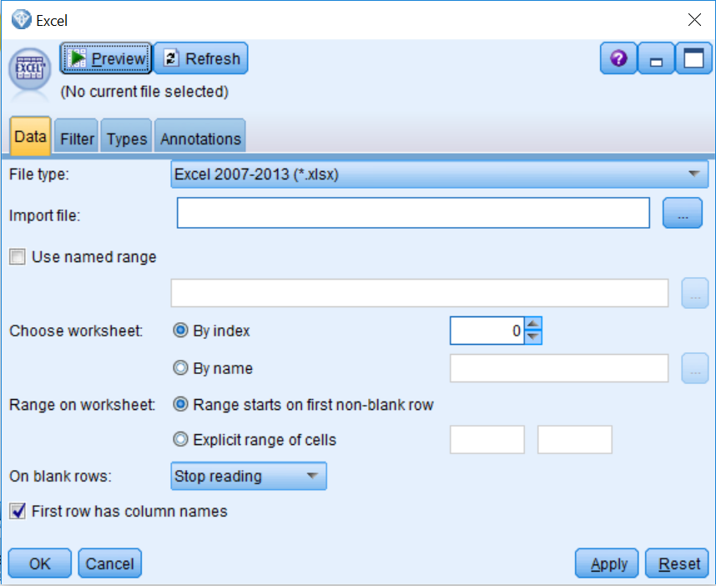

When using the Excel source node, you will first need to specify the type of Excel file that you are importing in the File type section. The filename and directory can be specified using the Import file list button. There are many other options in this dialog (descriptions of these options are presented in the following list). In our experience, the On blank rows option can be tricky because the default option specifies that once an empty row is encountered, Modeler will stop reading in data. This can be problematic because we have seen some datasets where there are blank rows (again, when a blank row is encountered, the data after the blank row is not read), or datasets where field names are in the first row. This is followed by a blank row, and then on the third row the data begins (in this case, we would only be reading in the field names).

Modeler only allows you to bring in one worksheet at a time (obviously, you can bring in other worksheets using additional Excel source nodes and then combine the files). The Use named range, Choose worksheet, and Range on worksheet options allow you to control this:

* Use named range specifies a named range of cells as defined in the Excel worksheet.
* Choose worksheet lets you specify which worksheet you want to import. Individual worksheets can be referred to either by name or index number. Index numbering begins with zero for the first worksheet, one for the second worksheet, and so forth.
* Range on worksheet lets you import an explicit range of cells in situations when you do not want to import the whole spreadsheet. With this option, you can either import the data beginning with the first non-blank row or specify an explicit range of cells.
* First row has column names indicates that the first row contains the names you want to use as field names. If not selected, field names will be generated automatically.

The Filter, Types, and Annotations tabs are the same in all source nodes, so we will not review these here.

**Database source node**

The Database source node imports data from a variety of packages that use **ODBC (Open Database Connectivity),** including Microsoft SQL Server, DB2, Oracle, and others. This node allows Modeler to read data directly from databases. Please note that before the Database node can be used, you must define your database as a data source (please refer to Database source node, under Help Topics, or click on dialog Help within a Database source node for additional information regarding defining data sources):

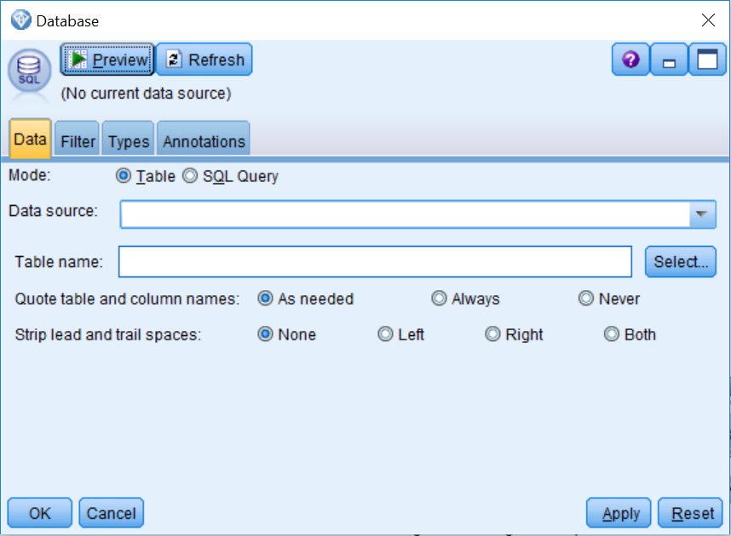

The Mode option (Table or SQL Query) allows you to select whether or not to view the tables/views within the database, or to enter/load an SQL query against the database.

To access data, you will need to either specify a data source or add a new database connection. Then you will need to specify which table you would like to add. Note that you can only bring in one table at a time. However, you can use another Database node to bring in additional tables, and these can be merged downstream.

Once you have specified the Data source and the Table name, the other options are:

* **Quote table and column names -** encloses table and column names in quotation marks when queries are sent to the database.
* **Strip lead and trail spaces -** controls how spaces in string fields are handled. Strings can be left and/or right trimmed.

# Levels of measurement and roles

As was mentioned previously, the Types tab is the most important tab within any source node. Let's take a closer look at the Types tab:

1. Edit the Var. File node.
2. Click on the Types tab.

The Field column displays each field's name. The Measurement column determines how Modeler will use each field. Initially, fields with numeric values are typed as Continuous, and fields with string values are typed as Categorical. It is important to make sure that when you are initially reading in data, you only have fields with the measurement levels Continuous or Categorical, if this is not the case, you can manually change this.

The current display is based on 50 lines of data and thus presents partially instantiated measurement levels. Measurement levels are fully instantiated when all data passes through the node.

Instantiation refers to the process of reading or specifying information, such as the measurement level and values for a field:

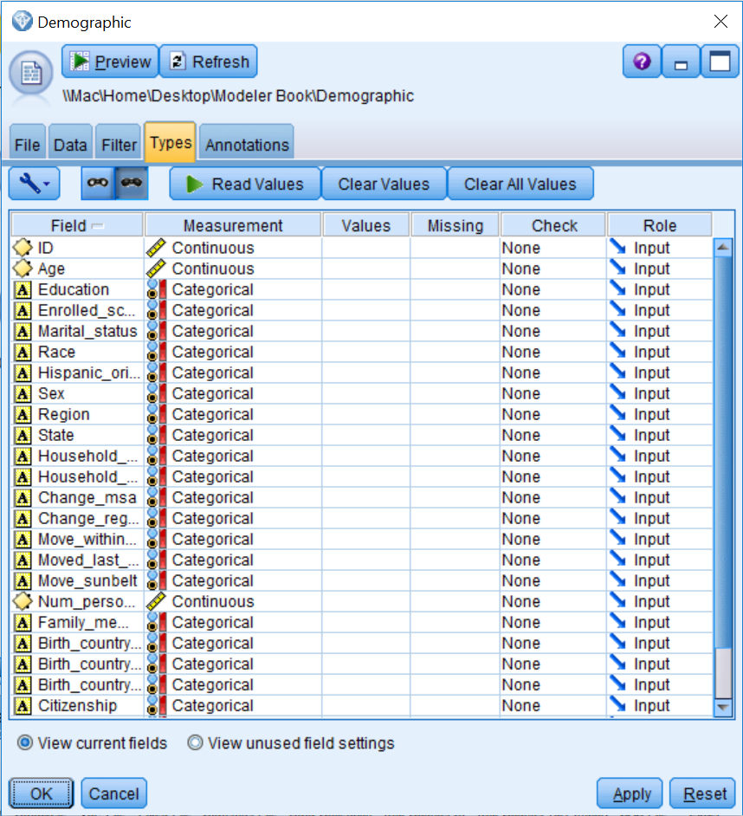

To instantiate the data:

1. Click Read Values.
2. Click OK.

Once the measurement levels have been instantiated, the values of the fields in the Values column of the Typestab are static at that point in the stream. This means that any upstream data changes will not affect the stored values of a particular field, even if you rerun the stream. To change or update the values based on new data or added manipulations, you need to edit them in the Types tab:

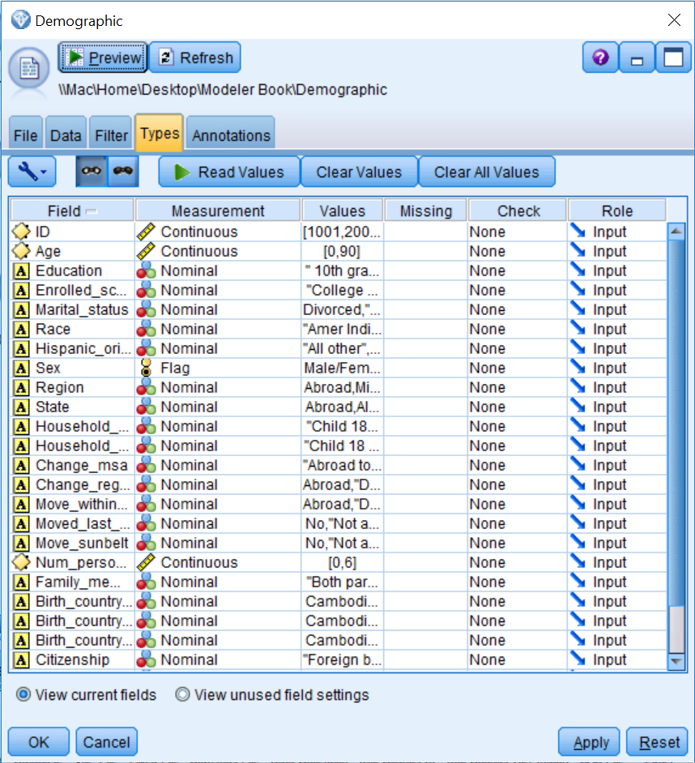

Notice that for Continuous fields, the Values column displays the minimum and maximum values. Also notice that the Categorical measurement level has disappeared (since it is temporary) and that string fields have now been assigned either a Flag, Nominal, or Ordinal measurement level. Also, for string fields, within the Values column the actual values are displayed.

The following table displays the definitions for each measurement level:

|  |  |
| --- | --- |
|  |  |
| **Measurement level** | **Definition** |
| Continuous | Numeric values where the numbers have real meaning (for example,  age = 42). A continuous value may be an integer, a real number, or  a date/time. |
| Categorical | String values when the exact number of distinct values is unknown  (before data is instantiated). |
| Flag | Data with two distinct values such as Yes/No or 1/0. |
| Nominal | Data with multiple distinct values, each treated as a member of a set,  such as Single, Married, or Divorced. |
| Ordinal | Data with multiple distinct values that have an inherent order, such as  1 = Very Satisfied, 2 = Satisfied, and 3 = Neutral. |
| Typeless | Data that does not conform to any of the other measurement levels,  or a categorical field with too many distinct values. |

Measurement level is important because it determines the type of descriptive statistics and analyses appropriate for a variable. For example, for categorical (Flag, Nominal, or Ordinal) variables, counts and percentages, as well as the mode (the category with the largest number of cases), are appropriate descriptive statistics. For continuous variables, counts and percentages are less interesting as there are usually a large number of distinct values. Rather, statistics that help us understand the overall distribution of the variable are most useful. Common descriptive information for continuous variables are the minimum and maximum values and the range of the distribution. Additional summary statistics such as the mean, median, and standard deviation help us further understand the distribution.

In Modeler, the measurement level takes on greater importance because many functions, nodes, and algorithms are specially designed only for certain levels of measurement, and so certain fields cannot be used if they are not of the appropriate measurement level. Thus, it is very important to check how each variable is defined within the Types tab. Let's change the measurement level for the field ID. This field contains a unique reference number and is better defined as Typeless as opposed to Continuous. Also, even though the fields Vet_benefits and Year use numeric values, these fields are really categorical fields, so therefore we should change them:

1. Click in the Measurement cell for the field ID.
2. Choose Typeless from the list.
3. Click in the Measurement cell for the field Vet_benefits.
4. Choose Categorical from the list.
5. Click in the Measurement cell for the field Year.
6. Choose Categorical from the list.
7. Click Read **Values**.
8. Click OK:

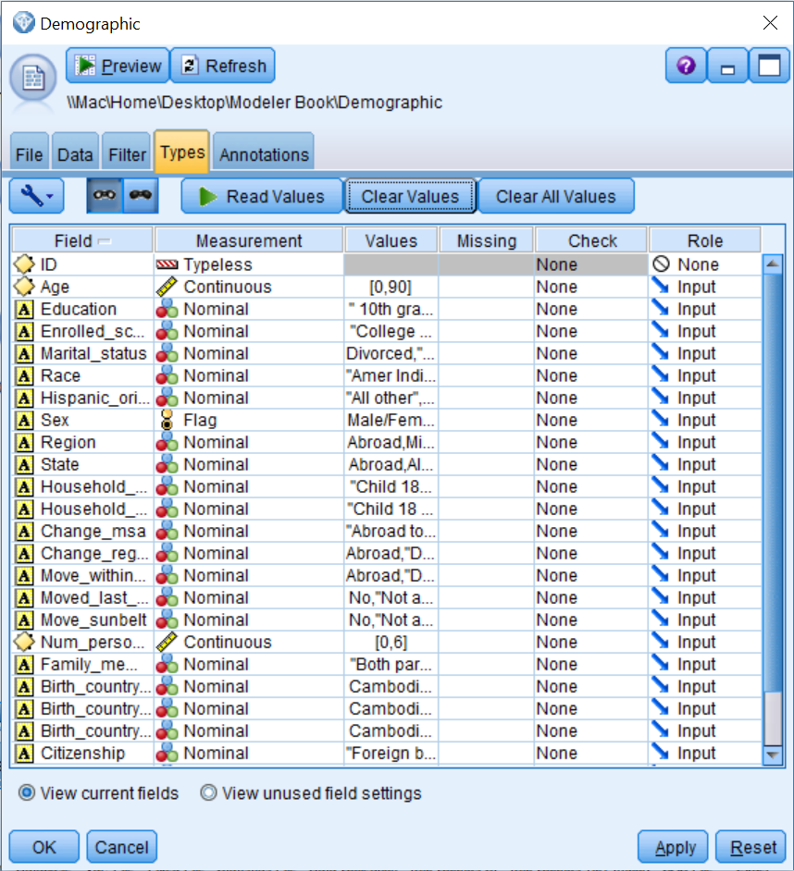

Notice that the field ID is now Typeless and the fields Vet_benefits and Year are defined as Nominal and Flag, respectively. As you will see, having the correct level of measurement is of the upmost importance.

We will discuss the Missing and the Check columns in an upcoming lesson. The Role column of a field specifies how each field will be used in modeling nodes. The following table displays the definition for each role:

|  |  |
| --- | --- |
| **Role** | **Definition** |
| Input | The field will be an independent variable or predictor in a model. |
| Target | The field will be the dependent variable or an outcome for a model. |
| Both | The field can be used as an Input or a Target in a model. This option is only  available for Association models. |
| None | The field will not be used in a model. |
| Partition | Indicates the field will be used to break up the data into separate samples for  training, testing, and (optional) validation purposes. |
| Split | Only available for categorical fields. Specifies that a model will be built for  each possible value of the split field. |
| Frequency | Only available for numeric fields. This role enables the field value to be used  as a frequency weighting factor for the record. This option is only applicable to  Linear, C&R Tree, CHAID, and Quest models. |
| Record ID | Only relevant for the linear node, where the specified field will be used as the  unique record identifier. |

You may have noticed that the role of the field ID changed from Input to None when its measurement level was changed to Typeless. This is because Typeless fields are not used in models, however they are kept so they can be used as identifiers in other nodes, such as the merge or distinct nodes. So, as with the measurement level, in Modeler field roles have implications regarding how they can be used for different functions, nodes, and algorithms. Typically, the Input role is the most common role. In our case, all of our current fields will be used as predictors in the model we will build, so Input is the appropriate role for now.

# Summary

In this chapter, you learned about the general data structure that is used in Modeler. You also learned how to read and display data in Modeler. Finally, you were introduced to the measurement level and field roles concepts.

In the next chapter, we will take a detailed look at how to assess data quality in Modeler. We will also discuss how to become familiar with the fields in a dataset so that we can identify errors or unusual values.

# Chapter 4 - Data Quality and Exploration

The previous chapter introduced the general data structure that is used in Modeler. You learned how to read and display data, and you were introduced to the concepts of the measurement level and the field roles. Now that you know how to bring data into Modeler, the next step is to assess the quality of the data. In this chapter you will:

* Get an overview of the Data Audit node options
* Go over the results of the Data Audit node
* Be introduced to missing data
* Discuss ways to address missing data

Once your data is in Modeler, you are ready to start exploring and become familiar with the characteristics of the data. You should review the distribution of each field so that you can become familiar with a dataset, but also so that you can identify potential problems that may arise. For continuous fields, you will want to inspect the range of values. For categorical fields, you will want to take a look at the number of distinct values. You will also have to consider whether you have outliers, and/or missing values (both the type and the amount).

Datasets always contain problems or errors, such as missing information and/or unusual values. Therefore, before modeling can begin, the quality of the data must be assessed. Modeler provides several nodes that can be used to investigate the integrity of the data. In our experience, the most important of these nodes is the Data Audit node. Typically, in most data mining projects, after bringing in data and making sure that it is read correctly, the Data Audit node is the next node that is used to better understand the data.

**Note**: In this chapter you will become familiar with the options available in the Data Audit node and the results produced by this node. However, in this chapter we are just interested in exploring the data. In the following chapter, we will fix some of the problems that we encounter.

# Data Audit node options

When data is first read into Modeler, it is important to check the data to make sure it was read correctly. Typically, using a Table node can help you get a sense of the data and inform you of some potential issues that you may have. However, the Data Audit node is a better alternative to using a Table node, as it provides a more thorough look at the data.

Before modeling takes place, it is important to see how records are distributed within the fields in the dataset. Knowing this information can identify values that, on the surface, appear to be valid, but when compared to the rest of the data are either out of range or inappropriate. Let's begin by opening a stream that has the modifications we made in the previous chapter:

1. Open the **Data Quality and Exploration** stream.

This simple stream contains the Demographic data file that has been linked to the Var. File source, along with the modifications we previously made in the Types tab. In order for this stream to function correctly, you will need to ensure that the link to the data file is pointing to the correct location.

1. To use the Data Audit node, click on the Output palette.
2. Double-click on the Data Audit node so that it is connected to the Var. File node.

The **Data Audit** node provides a first look at the data by providing summary statistics, histograms, or distribution charts for each field, as well as information on missing data, outliers, and extreme scores:

1. Edit the Data Audit node:

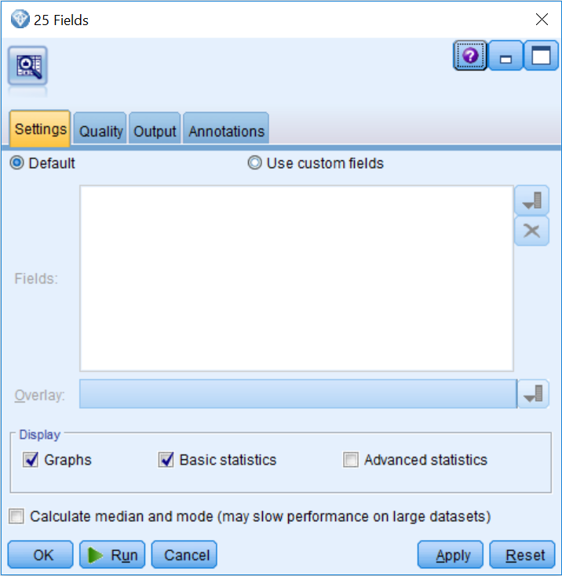

The **Settings** tab controls which fields will be included in the analysis and which statistics and graphs will be reported. In our experience, most of the time the default options are ideal; however, these can certainly be modified:

* The**Default** option includes all fields in the analysis that do not have their role set to None.
* The **Use custom fields** option allows you to choose which fields will be included. If custom fields are selected, the Overlay field list allows the distribution of a categorical field to appear over the distribution of the fields selected in the Field list.
* The **Display** option controls whether graphs are created and which summary statistics will be calculated. Since median and mode statistics require more computational resources than basic statistics, they constitute a separate option. The **Advanced statistics** option, which we will not use in this example, displays the sum, range, variance, and kurtosis for each field.

Lets look at some additional options:

1. Click on the Quality tab:

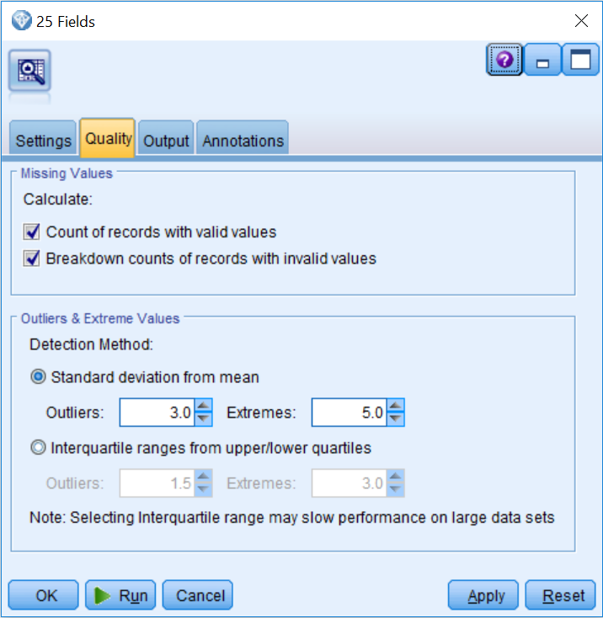

The **Quality** tab controls the options for checking missing data and determining what values are considered to be outliers and extreme cases. Again, in our experience, the default options tend to do a good job most of the time. The following is a description of the options on this tab:

* The **Count of records with valid values** option displays the total number of records with valid values for each selected field.
* The **Breakdown counts of records** **with invalid values** option displays the number of records with each type of invalid value for each field.
* The **Detection Method** option allows users to specify how outliers and extreme values will be determined. This can be based on either the distance away from the mean (standard deviation) or the distance away from the interquartile range.

1. To see the results of the Data Audit node, click the Run button.

# Data Audit node results

Each row of the **Audit** tab of the **Data Audit** output represents a field, and the columns contain graphs, measurement level information, and summary statistics. The **Data Audit** node reports different statistics and graphs depending on the measurement level of the fields. This is one of the reasons why it is important to set the correct measurement level before running the **Data Audit** node:

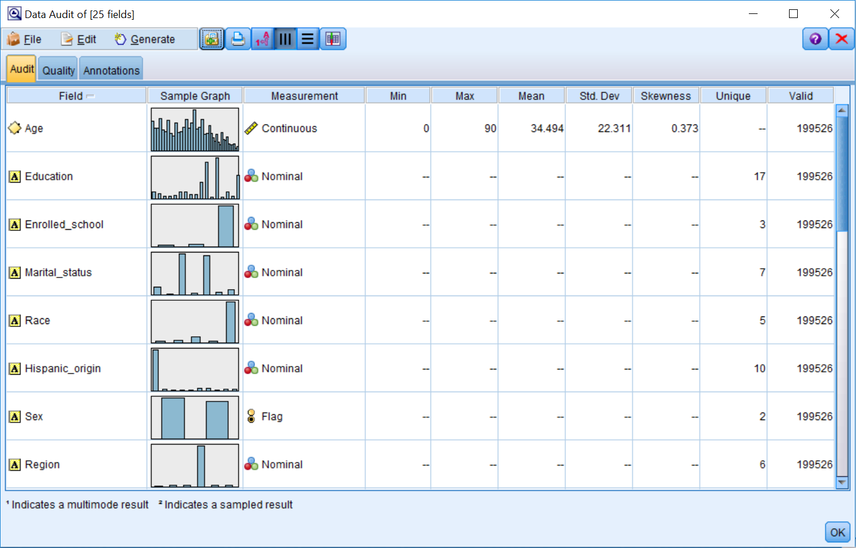

For Categorical fields, the **Data Audit** node reports the number of unique values, which is the number of unique categories. For Continuous fields, the **Data Audit**node reports on the Min (minimum), Max (maximum), Mean, standard deviation (Std. Dev, indicating the spread in the distribution), and Skewness (a measure of the asymmetry of a distribution). The Valid column reports the number of valid cases (that is, cases without missing data) for any type of field.

The **Data Audit** node produces a histogram for Continuous fields, and a bar chart for Categorical fields. Graphs are displayed as thumbnails in the initial report, but if you double-click on the thumbnails you can generate full-sized graphs.

You will want to review the distribution of each field as well as the number of valid cases. When you have a Categorical field, it is important to see how many unique values there are, and make sure there are not more than the expected number of categories. It is also important to determine how the records are distributed among the categories of a field. You might want to look for categories with either very few or a large amount of records. In either instance, this can be problematic for modeling. For Continuous fields, there is usually interest in the distribution of the data values (unusual distributions, such as those that are highly skewed or bimodal) and summary statistics (for example, having a lower minimum than expected, a higher maximum than expected, a different mean than expected, or more or less variation than expected).

In our example, all the fields have a total of 199526 valid cases, and coincidentally this is how many cases are presented in the file. Because of this, it seems that we have no missing data, but we will further explore this a little later in the chapter. In terms of our actual data mining project, we are eventually going to try to predict the income (the income field is in another file that we will bring in later). Specifically, we are going to try to determine who makes more or less than $50,000 a year. One field that is typically related to income is education. The field Education has 17 unique values; we want to ask ourselves if this is what we expected. To take a closer look at a field, you can double-click on a thumbnail.

The following screenshot displays information for the field Education:

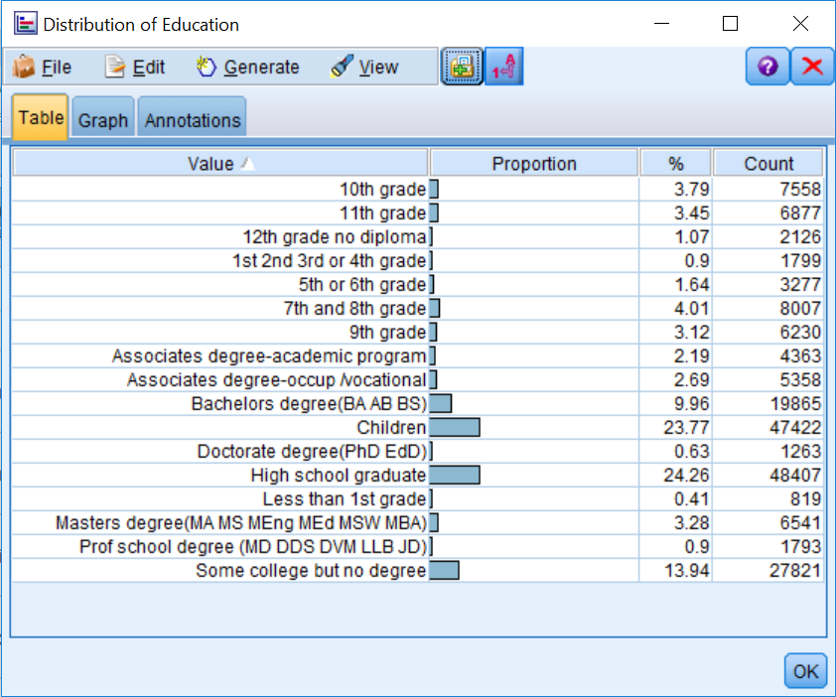

Double-clicking on a thumbnail in the Data Audit output window creates the graph (distribution plot or histogram) in its own window. For distribution plots, category labels will appear along with count and percent summaries. This graph is added as a new object in the Outputs manager.

When we examine the distribution of the field Education, we can see that there are 17 different options that were used in this dataset. So, here we want to ask ourselves if the distribution of this variable makes sense. Is this what we were expecting? Do we notice any errors? Do we see any potential problems when analyzing this data? For example, often categories with very few cases (less than 5%) can be problematic for models, so we might need to exclude these values when building a model, or possibly combine them with other values, if that makes sense. Because the Education variable has several categories with few values, here we could begin to get an idea of how to possibly combine categories, and maybe create a new field that has the values no high school degree, high school degree, some college, bachelors degree, and advanced degree.

Note that the preceding example is only one way to collapse the Education field. Feel free to try out different options. The only caveat is that the categories should make sense (that is, do not combine the ninth grade with a doctorate degree).

One other troubling finding for this field is that we have a category called children. From an ethical perspective, maybe we should not have included children in this research. From a practical point of view, including children could artificially inflate the accurateness of our model, because it would seem that most children will probably make less than $50,000 a year.

To better see if we have children in the dataset, let's take a closer look at the field Age. The summary statistics show that the average age in the dataset is 34.5 and that the ages range from 0 to 90:

1. Double-click on the thumbnail for the field Age:

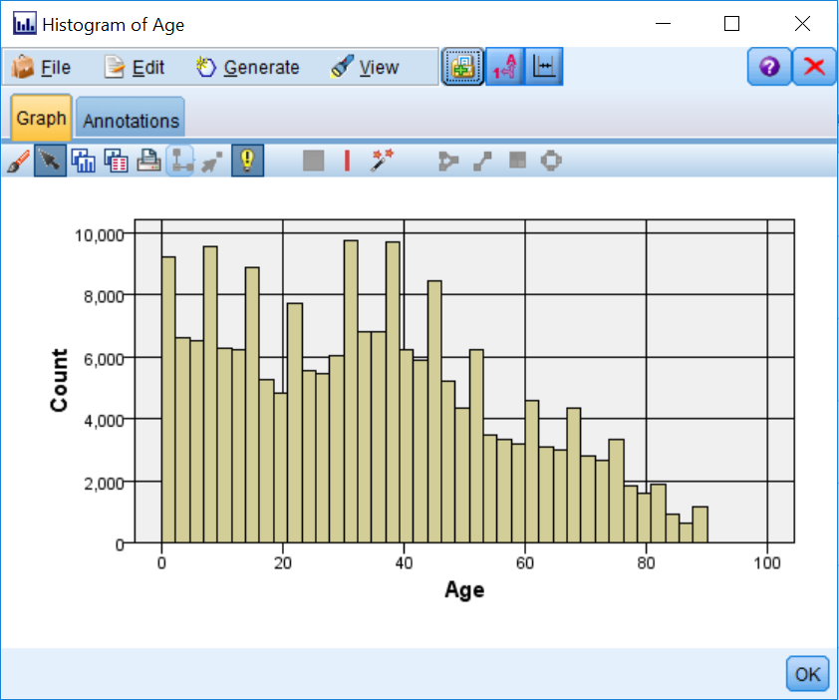

Note that there are quite a few people in this dataset that are children (their age is less than 18). We will remove these individuals in the next chapter.

1. Let's take a look at another field. Double-click on the thumbnail for the field Household_summary:

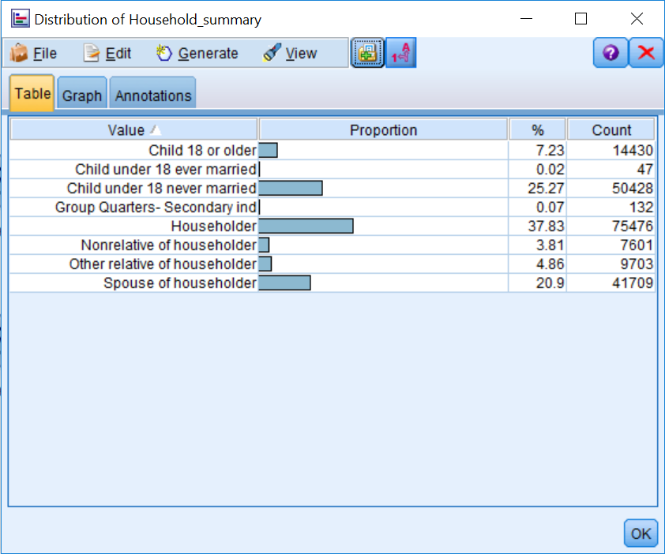

At first glance, the Household_summary field seems okay (aside from containing a few categories with low counts); however, upon further inspection, we can see that the category Child under 18 ever married is a misspelled version of the category Child under 18 never married. Again, we will fix this misspelling in the next chapter.

Let's take a look at another field.

1. Double-click on the thumbnail for the field Vet_benefits:

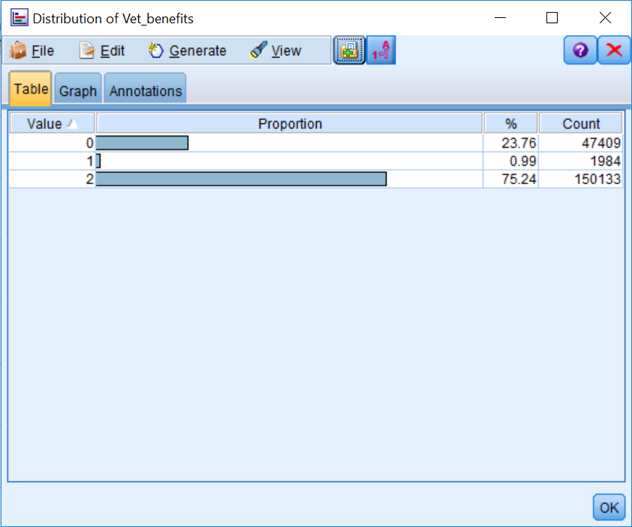

The field Vet_benefits is a nominal field with three values (yes, no, and not applicable); however, these values have been coded numerically. This in and of itself is not a problem (and in fact, it may be a requirement for some statistical models); however, interpretation is certainly easier when we have a label instead of a numeric value. In the next chapter, we will also show you how to fix this issue.

Let's take a look at one last field.

1. Double-click on the thumbnail for the field Region:

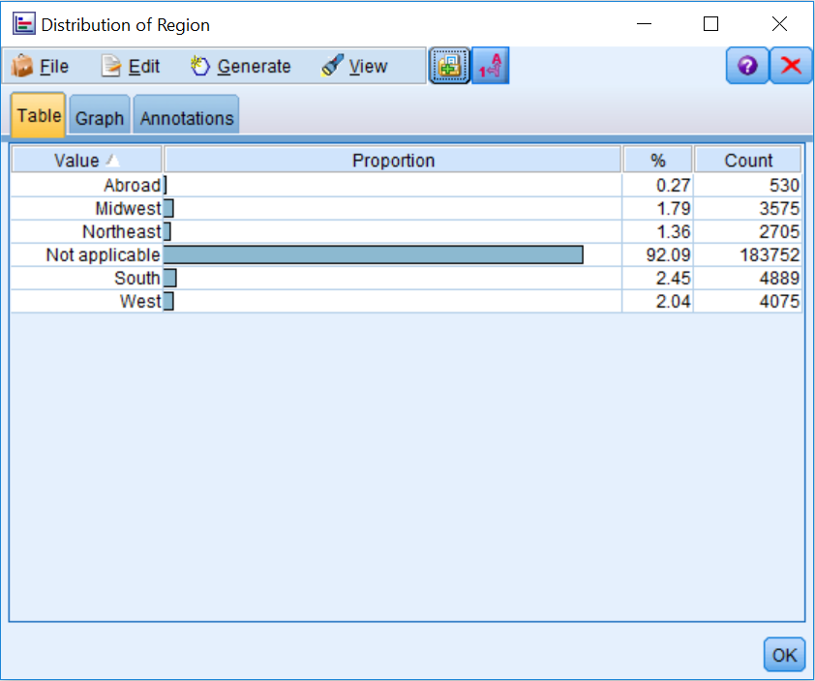

This field attempts to identify the current region where each person resides. Naturally, there are categories for different regions in the US, and there is even an Abroad category. However, the vast majority of respondents have selected the option Not applicable, and in this case, since everyone has to live either somewhere in the US or abroad, Not applicable really stands for missing data. Next, we will further elaborate on the notion of missing data, and after that we will discuss the options for handling missing data.

Before moving on to look at the options in the **Quality** tab of the **Data Audit** node output, take some time to further explore the other fields. For example, the birth country fields should be transformed into Flag fields with values of US or other values, given the low counts of most of the categories.

# The Quality tab

1. The **Quality** tab of the **Data** **Audit** node output focuses on identifying outliers and missing data. It provides the number and percentages of valid values, as well as a breakdown of the different types of missing values:
2. Click on the **Quality** tab.

Lets look at some additional information:

1. **Outliers** and **Extremes** show how many outliers and extreme values correspond to each field. Outliers and extremes only apply to Continuous fields, and the definitions of these values were defined in the **Quality** tab of **the Data Audit** node (by default, outliers are defined as values more than three standard deviations from the mean, and extremes are defined as values more than five standard deviations from the mean).

* **Action** allows users to specify what action, if any, will be taken to remedy the number of outliers and extreme values.

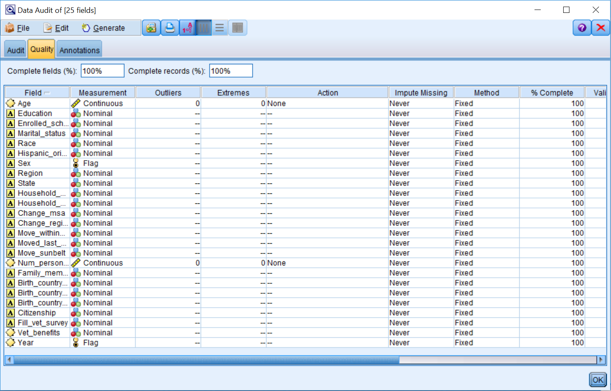

Outlier data values, unlike other data values, can be problematic for several modeling techniques. At times, outliers can be errors in the data, for example, a school teacher with a salary of $1,000,000; most likely an extra zero was added during data entry. Unusual cases can be extreme scores, for example, a customer who purchased 5,000 speakers during the last month, where typically monthly orders range from 100 to 1,000 speakers per month. At other times, unusual cases can be interesting cases, for example, a patient with cystic fibrosis who is 52 years old, when the life expectancy for this disease is in the mid-30s. In addition, unusual cases can be valuable, for example, there might a small group of customers that use their cell phones a lot. This group is valuable as customers, but we might want to analyze their data separately so they do not distort the findings for typical customers. Finally, unusual cases can be a real cause for concern, for example, when investigating insurance fraud. In any of these situations, outliers can produce biased results from a model.

With regards to missing data, first of all, Modeler reports on the overall percentage of fields and records that are complete. In addition, Modeler further breaks down this information by field:

* % Complete expresses the percentage of the total number of complete records per field
* Valid Records shows the number of valid values for each field, which is followed by columns for the four types of missing values that you can have in Modeler: Null value, Empty string, White space, and Blank value
* Impute Missing allows users to specify if and when missing values will be imputed
* Method shows how missing values will be imputed

This report can be sorted by values within any of the columns by clicking on the column header.

# Missing data

Missing data is different than other topics in that you cannot just choose to ignore it. This is because failing to make a choice just means you are using the default option for a procedure, which most of the time is not optimal. In fact, it is important to remember that every model deals with missing data in a certain way, and some modeling techniques handle missing data better than others.

As was alluded to previously, in Modeler there are four types of missing data:

|  |  |
| --- | --- |
| **Type of missing data** | **Definition** |
| $Null$ value | Applies only to numeric fields. This is a cell that is empty or has  an illegal value. |
| White space | Applies only to string fields. This is a cell that is empty or has  spaces. |
| Empty string | Applies only to string fields. This is a cell that is empty.  Empty string is a subset of white space. |
| Blank value | This is predefined code, and it applies to any type of field. |

The first step in dealing with missing data is to assess the type and amount of missing data for each field. Consider whether there is a pattern as to why data might be missing. This can help determine if missing values could have affected responses. Only then can we decide how to handle it.

There are two problems associated with missing data, and these affect the quantity and quality of the data:

* Missing data reduces sample size (quantity)
* Responders may be different from nonresponders (quality—there could be biased results)

# Ways to address missing data

There are three ways to address missing data:

* Remove fields
* Remove cases
* Impute missing values

It can be necessary at times to remove fields with a large proportion of missing values. The easiest way to remove fields is to use a Filter node (discussed later in the book), however you can also use the Data Audit node to do this.

**Note:** that in some cases missing data can be predictive of behavior, so it is important to assess the importance of a variable before removing a field.

In some situations, it may be necessary to remove cases instead of fields. For example, you may be developing a predictive model to predict customers' purchasing behavior and you simply do not have enough information concerning new customers. The easiest way to remove cases would be to use a Select node (discussed in the next chapter); however, you can also use the Data Audit node to do this.

Imputing missing values implies replacing values for fields. However, some people do not estimate values for categorical fields because it does not seem right. In general, it is easier to estimate missing values for numeric fields, such as age, where often analysts will use the mean, median, or mode.

Note that it is not a good idea to estimate missing data if you are missing a large percentage of information for that field, because estimates will not be accurate. Typically, we try not to impute **more than 5% of values.**

To close out of the Data Audit node:

1. Click OK to return to the stream canvas.

# Defining missing values in the Type node

When working with missing data, the first thing you need to do is define the missing data so that Modeler knows there is missing data, otherwise Modeler will think that the missing data is another value for a field (which, in some situations, it is, as in our dataset, but quite often this is not the case).

Although the Data Audit node provides a report of missing values, blank values need to be defined within a Type node (or Type tab of a source node) in order for these to be identified by the Data Audit node. The Type tab (or node) is the only place where users can define missing values (Missing column).

**Note:** In the Type node, blank values and $null$ values are not shown; however, empty strings and white space are depicted by "" or " ".

To define blank values:

1. Edit the Var.File node.
2. Click on the Types tab.
3. Click on the Missing cell for the field **Region**.
4. Select Specify in the Missing column.
5. Click Define blanks.

Selecting **Define blanks** chooses Null and White space (remember, Empty String is a subset of White space, so it is also selected), and in this way these types of missing data are specified. To specify a predefined code, or a blank value, you can add each individual value to a separate cell in the Missing values area, or you can enter a range of numeric values if they are consecutive.

1. Type **"Not applicable"** in the first Missing values cell.
2. Hit Enter:

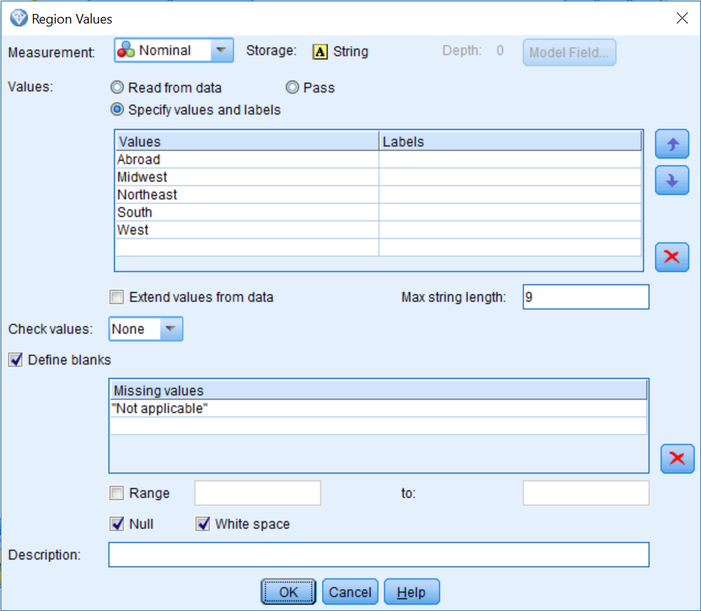

We have now specified that "**Not applicable"** is a code for missing data for the field Region.

1. Click OK.

In our dataset, we will only define one field as having missing data.

1. Click on the Clear Values button.
2. Click on the Read Values button:

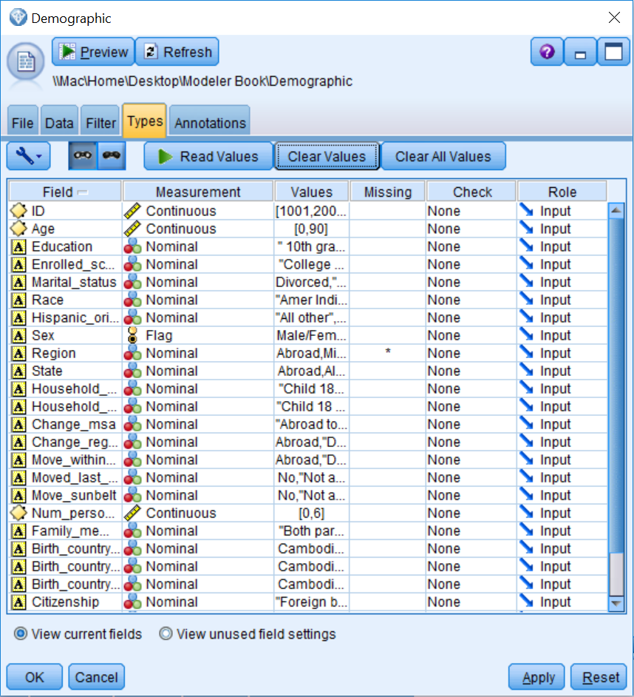

The asterisk indicates that missing values have been defined for the field Region. Now Not applicable is no longer considered a valid value for the field Region, but it will still be shown in graphs and other output. However, models will now treat the category Not applicable as a missing value.

1. Click OK.

# Imputing missing values with the Data Audit node

As we have seen, the Data Audit node allows you to identify missing values so that you can get a sense of how much missing data you have. However, the Data Audit node also allows you to remove fields or cases that have missing data, as well as providing several options for data imputation:

1. Rerun the Data Audit node.

**Note**: The field Region only has 15,774 valid cases now, because we have correctly identified that the Not applicable category was a predefined code for missing data.

1. Click on the Quality tab.

We are not going to impute any missing values in this example because it is not necessary, but we are going to show you some of the options, since these will be useful in other situations. To impute missing values you first need to specify when you want to impute missing values. For example:

1. Click in the Impute when cell for the field Region.
2. Select the Blank & Null Values.

Now you need to specify how the missing values will be imputed.

1. Click in the Impute Method cell for the field Region.
2. Select Specify.

In this dialog box, you can specify which imputation method you want to use, and once you have chosen a method, you can then further specify details about the imputation. There are several imputation methods:

* **Fixed** uses the same value for all cases. This fixed value can be a constant, the mode, the mean, or a midpoint of the range (the options will vary depending on the measurement level of the field).
* **Random** uses a random (different) value based on a normal or uniform distribution. This allows for there to be variation for the field with imputed values.
* **Expression** allows you to create your own equation to specify missing values.
* **Algorithm** uses a value predicted by a C&R Tree model.

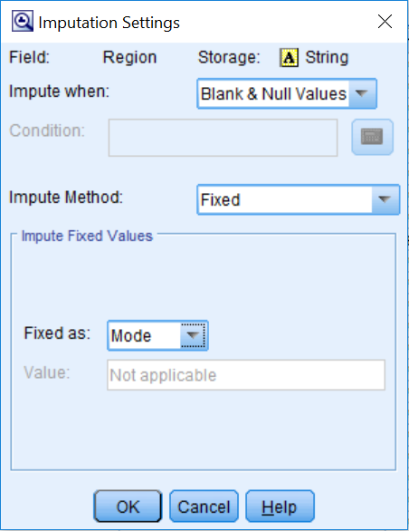

We are not going to impute any values now so click Cancel.

If we had selected an imputation method, we would then:

1. Click on the field Region to select it.
2. Click on the Generate menu.

The Generate menu of the Data Audit node allows you to remove fields, remove cases, or impute missing values, explained as follows:

* **Missing Values Filter Node**: This removes fields with too much missing data, or keeps fields with missing data so that you can investigate them further
* **Missing Values Select Node**: This removes cases with missing data, or keeps cases with missing data so that you can further investigate
* **Missing Values SuperNode**: This imputes missing values:

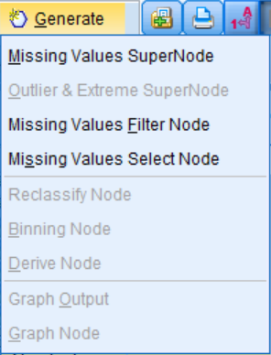

If we were going to impute values, we would then click Missing Values SuperNode. This is how you can impute missing values.

# Summary

This chapter focused on understanding your data. You learned about the different options available in the Data Audit node. You also learned how to look over the results of the Data Audit node to get a better feel for your data and to identify potential problems your data may have. Finally, you were introduced to the topic of missing data, and several ways to address this issue were discussed.

In the next chapter, we will begin to fix some of the problems that we found in the data. Specifically, we will use the Select node to choose the appropriate sample for our analysis. We will also use the Reclassify node to modify fields so that the distributions are appropriate for modeling. We will also use other nodes to rectify other concerns.

# Chapter 5 - Cleaning and Selecting Data

The previous chapter focused on the data understanding phase of data mining. We spent some time exploring our data and assessing its quality. The previous chapter also mentioned that the Data Audit node is usually the first node that is used to explore and assess data. You were introduced to this node's options and learned how to look over its results. You were also introduced to the concept of missing data and shown ways to address it. In this chapter, you will learn how to:

* Select cases
* Sort cases
* Identify and remove duplicate cases
* Reclassify categorical values

Having finished the initial data understanding phase, we are ready to move onto the data preparation phase. Data preparation is the most time-consuming aspect of data mining. In fact, even in this very brief introductory book, we are devoting several chapters to this topic because it will be an integral part of every data mining project. However, every data mining project will require different types of data preparation. In the next few chapters we will introduce some very commonly used nodes. You will certainly use some of these nodes in your own work, but do not be surprised if you also have to use additional nodes that are not covered in this book.

Data understanding is something we are always trying to achieve, because we can always learn more from and about the data. Part of data understanding is having extensive knowledge on the subject matter, part of it is exploring and assessing data quality (which we began looking at in the previous chapter), and part of it is understanding the relationships between the fields (which we will do in a later chapter).

There is no prescribed order as to how to tackle data preparation. We could certainly begin by combining various data files, or we could create new fields at this point. In our experience, a good way to start is by addressing some of the problems or errors that were found in the dataset during the initial data understanding phase. In doing this, we can get a better sense of the data. As a general point, having higher quality data will lead to more accurate predictions, which will lead to more useful and trustworthy results. For this project, based on our findings from the Data Audit node, the biggest issue with this dataset is that we have included children in the file, therefore we need to remove these cases. Let's begin by choosing the appropriate records.

# Selecting cases

Often during a data mining project, you will need to select a subset of records. For example, you might want to build a model that only includes people that have certain characteristics (for example, customers who have purchased something within the last six months). The **Select** node is used when you want to select or discard a subset of records based on a specific condition. Let's go through an example of how to use the **Select** node:

1. Open the **Cleaning and Selecting data** stream.
2. Click on the Record Ops palette.
3. Double-click on the Select node so that it is connected to the Var.File node.
4. Right-click on the Select node, then click Edit:

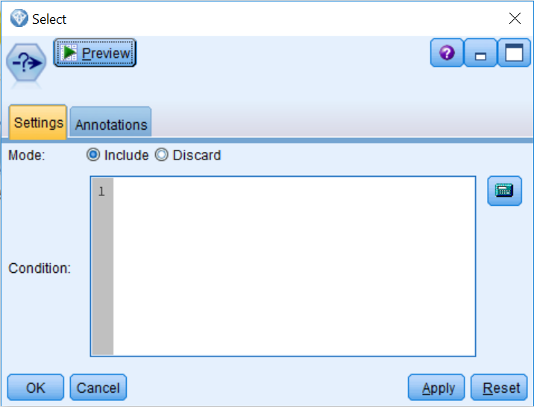

The **Select** node allows users to specify an expression either directly in the **Condition** text box or with the **Expression Builder** (the calculator icon). The **Mode** option allows you to choose whether to select (Include) or delete (Discard) records that satisfy the condition.

You can type the selection criteria into the **Condition** textbox, but it is often easier to invoke the Expression Builder, in which you can create an expression by clicking on the operation buttons and selecting fields and functions from list boxes.

1. Click on the Expression Builder.

# Expression Builder

Expressions are built in the large textbox. Operations (addition, subtraction, and so on) can be pasted into the expression textbox by clicking the corresponding buttons. The Function list contains functions available in Modeler:

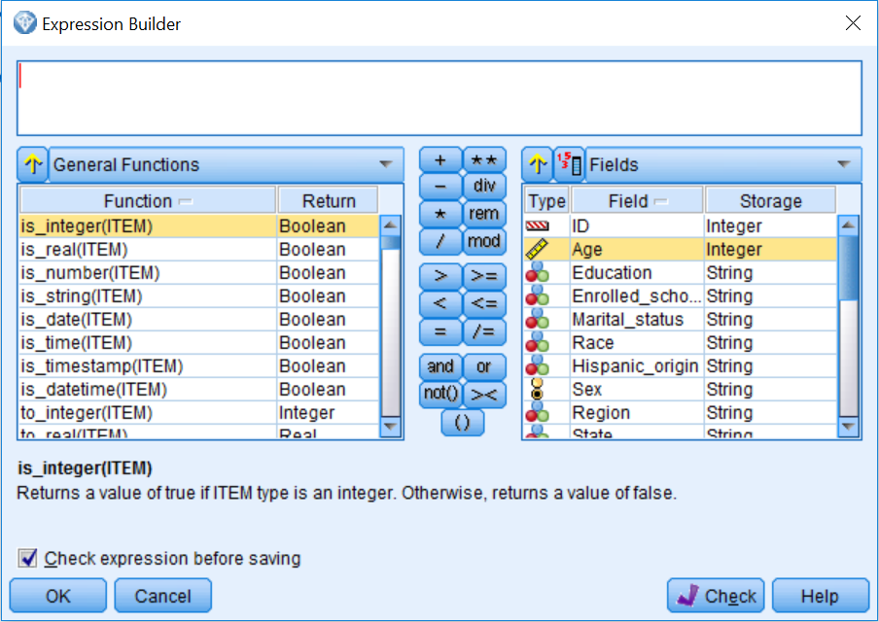

By default, a general list of functions appears, but you can use the drop-down list above the Function list box to display functions of a certain type (for example, date and time functions, numeric functions, logical functions, and so on). Similarly, by default, all fields (and categories within a field) in the stream are listed in the Field list box and can be pasted into the expression by clicking the Insert button after the field is selected. As an example:

1. Click on the field Education.
2. Once the field Education is selected, click on the field values button (the button with the numbers one, three, and five):

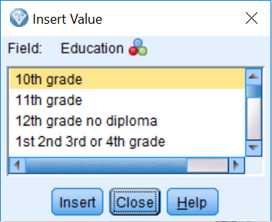

Notice that at this point we can use any of the values for the field Education if we need to. In our case, we are going to select everybody over the age of 17. To do this:

1. Close the field values dialog box.
2. Double-click on the field Age.
3. Click on the > sign.
4. Type 17.

Your selection criteria is now specifying that anyone over the age of 17 is to be selected:

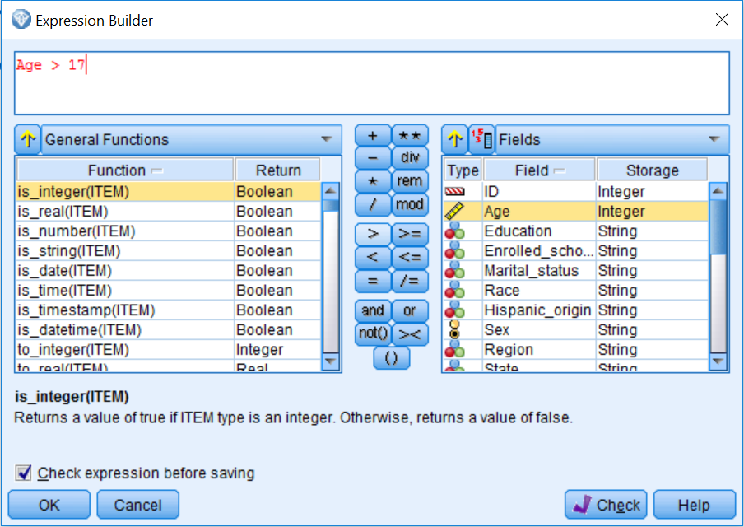

1. Click OK.

Because the Mode is set to Include, we are keeping anyone that meets the selection criteria and removing anyone that does not meet the criteria:

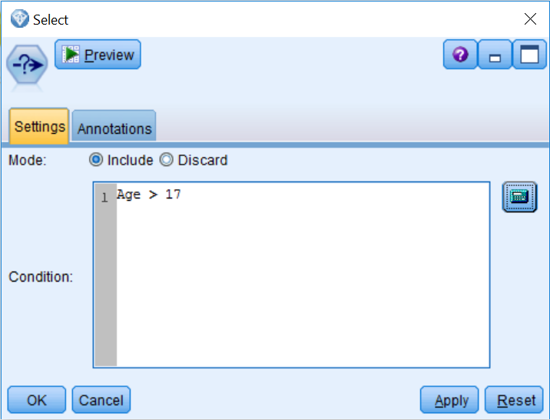

1. Click OK.

Now let's take a look at the results from the Select node:

1. Connect the Select node to a Table node.
2. Run the Table.

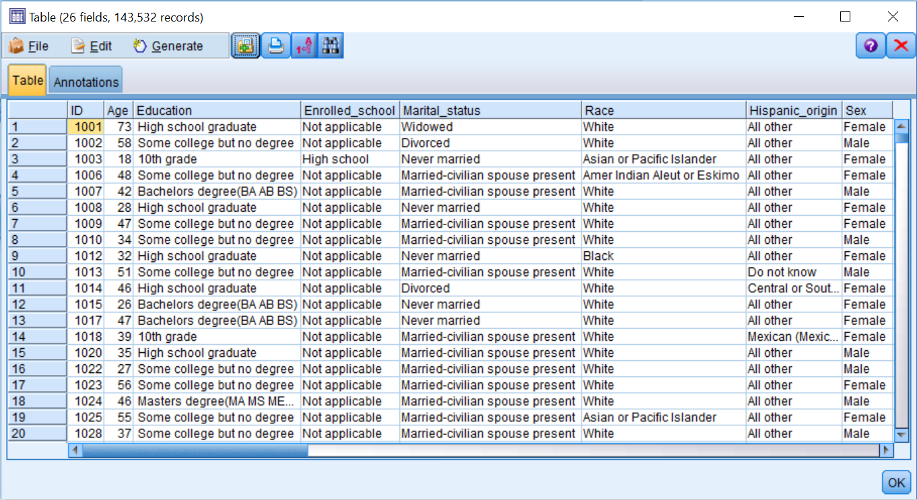

Notice that there are 143,532 records in the dataset, instead of the original 199,526 cases. At this point, all the nodes downstream of the Select node will analyze only records that are 18 years of age or older.

If you run the Table node below the Var. File node, you will notice that there are 199,526 records in this table, which are all of the records in the original dataset (not shown). In this case, the selection does not apply because this table is not downstream from the Select node.

To quickly check on the previous command, we will rank the data file by age using a Sort node to ensure that we have selected all of the records of interest.

In this example, we selected records based on one simple criterion, however we could have made the selection criteria as simple or complex as the situation required.

# Sorting cases

At times it is useful to see if any values look unusual. The **Sort** node arranges cases into ascending or descending order based on the values of one or more fields. It also helps in the optimization of other nodes so that they perform more efficiently:

1. Place a Sort node from the Record Ops palette onto the canvas.
2. Connect the Select node to the Sort node.
3. Edit the Sort node.

You can sort data on more than one field. In addition, each field can be sorted in ascending or descending order:

1. Click on the Field Chooser button.
2. Select Age in the Sort by: fieldbox.
3. Click OK:

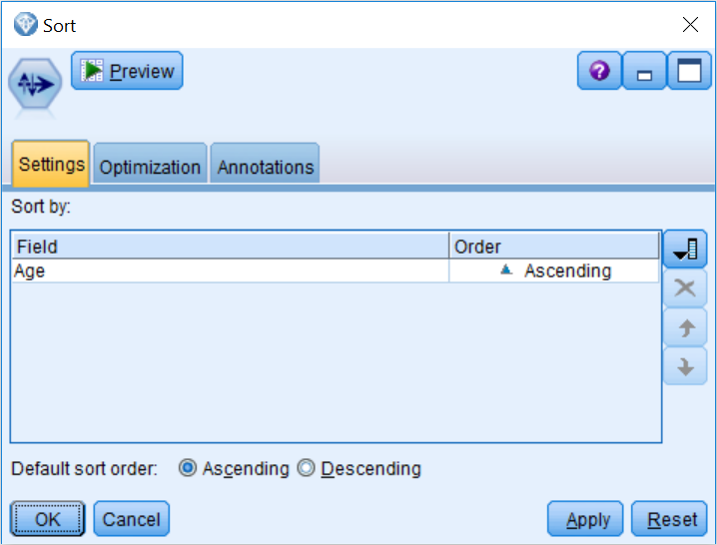

We will now rank the age cases in ascending order (the youngest people will be at the top of the file and the oldest people will be at the bottom of the file):

1. Click OK.

Now let's take a look at the results from the Sort node:

1. Connect the Sort node to a Table node.
2. Run the Table node:

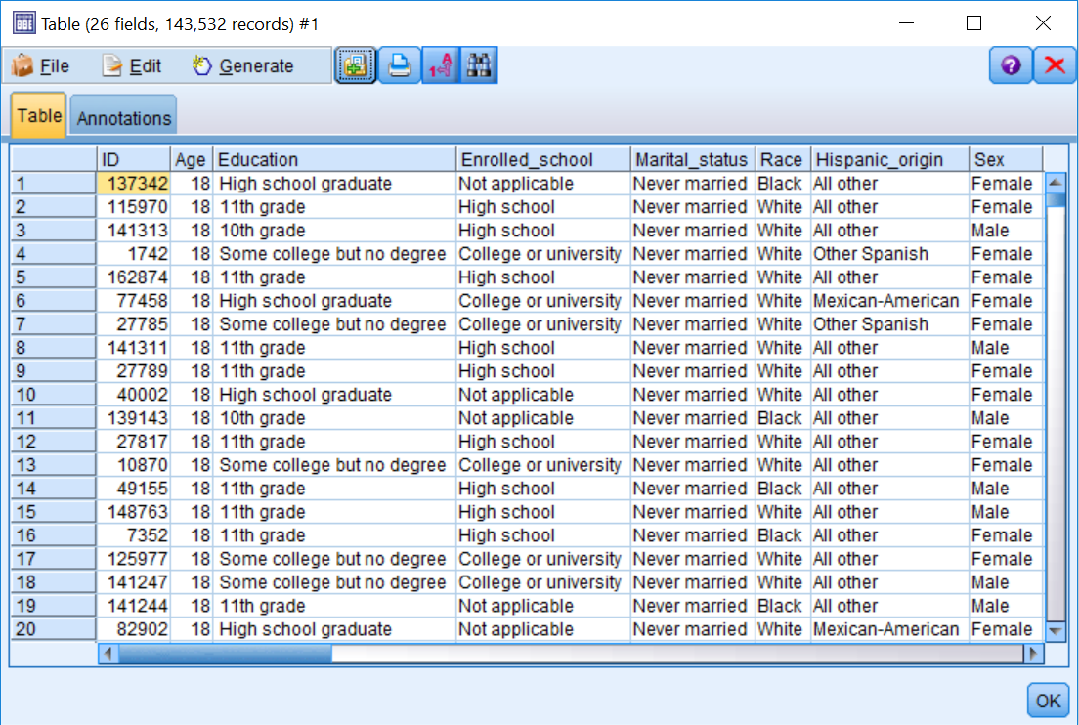

Notice that there are no longer any children in this file, as the youngest people in the dataset are 18 years old.

# Identifying and removing duplicate cases

Datasets may contain duplicate records that often must be removed before data mining can begin. For example, the same individual may appear multiple times in a dataset with different addresses. The Distinct node finds or removes duplicate records in a dataset. The **Distinct** node, located in the Record Ops palette, checks for duplicate records and identifies the cases that appear more than once in a file so they can be reviewed and/or removed.

A duplicate case is defined by having identical data values on one or more fields that are specified. Any number or combination of fields may be used to specify a duplicate:

1. Place a Distinct node from the Record Ops palette onto the canvas.
2. Connect the Sort node to the Distinct node.
3. Edit the Distinct node.

The **Distinct** node can be a bit tricky to use; this is why we will run this node a couple of times, and hopefully in this way its options will become well-defined. The Mode option controls how the **Distinct** node is used. To remove duplicates in a dataset, the Mode should be set to Include only the first record in each group; in this way, the first time a record is identified it will pass, however subsequent encounters will be removed. To identify duplicates, set the mode to **Discard** only the first record in each group; this option removes the record the first time it is identified, however subsequent encounters will be kept, and in this way the duplicates will be identified. The Create a composite record for each group option provides a way to aggregate non-numeric fields which you can specify on the Composite tab to create composite records.

In this example, we will use the **Distinct** node to identify all the duplicate cases in a data file. The fields that provide the basis for identification of duplicates are selected in the Key fields for grouping box.

**Note**: The **Distinct** node will function even if the data is not sorted. However, it is best to sort the data beforehand, either by using the Sort node or by specifying a sort field(s) in the Distinct node dialog itself, in the Within groups, sort records by: area. Sorting makes checking the operation of the Distinct node more straightforward, and clearly, if there is a natural ordering to the data such that the first record in agroup of duplicates is to be preferred, sorting beforehand is a necessity.

1. Place all the fields in the Key fields for grouping: box (by using all of the fields, we are looking for cases that are exact duplicates in all of the fields).
2. Make sure Mode: Discard only the first record in each group is selected:

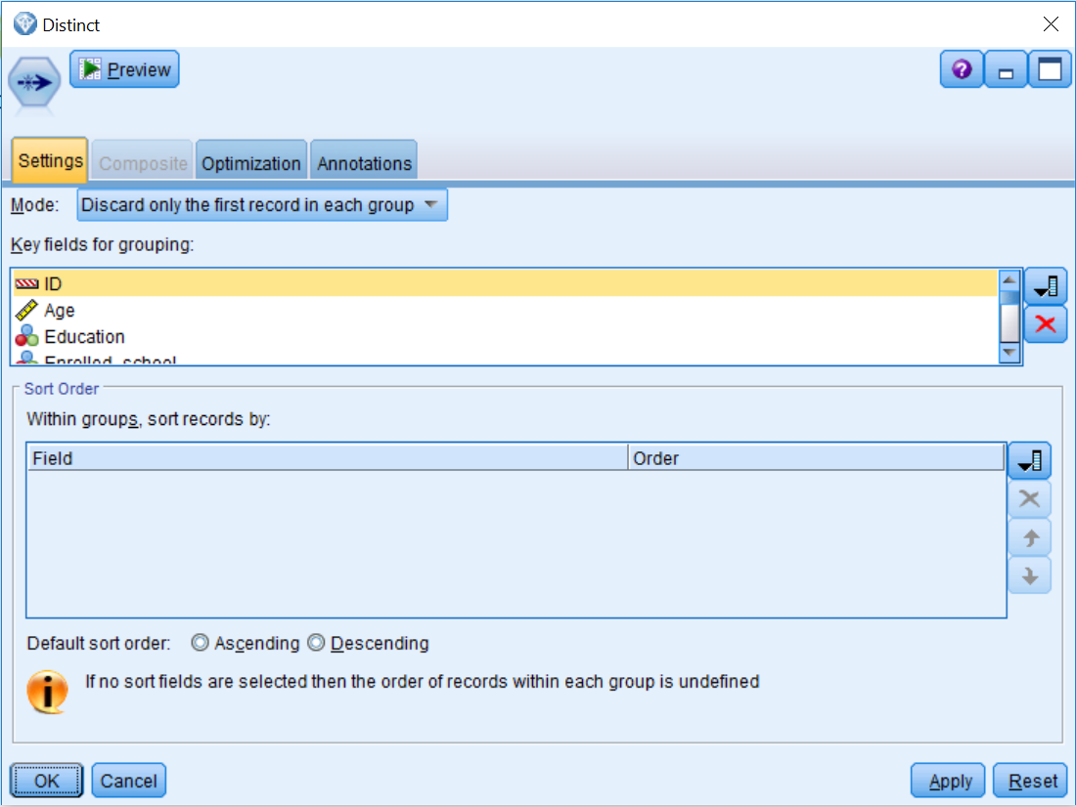

1. Click OK to return to the stream canvas.
2. Connect the Distinct node to a Table node.
3. Run the Table node:

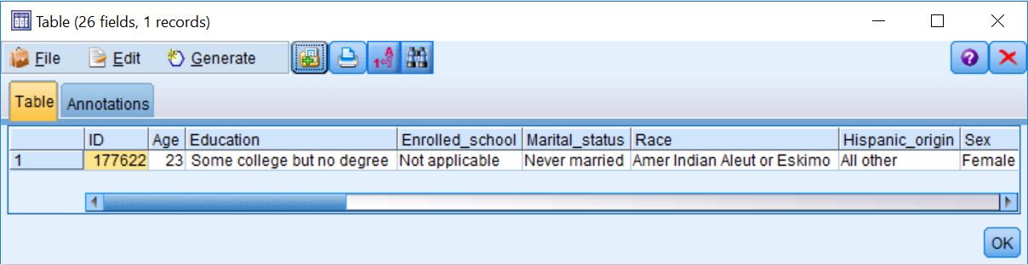

There is only one case in the data file that is an exact duplicate. We will now remove this case:

1. Edit the Distinct node.
2. Select Include only the first record in each group for the Mode:

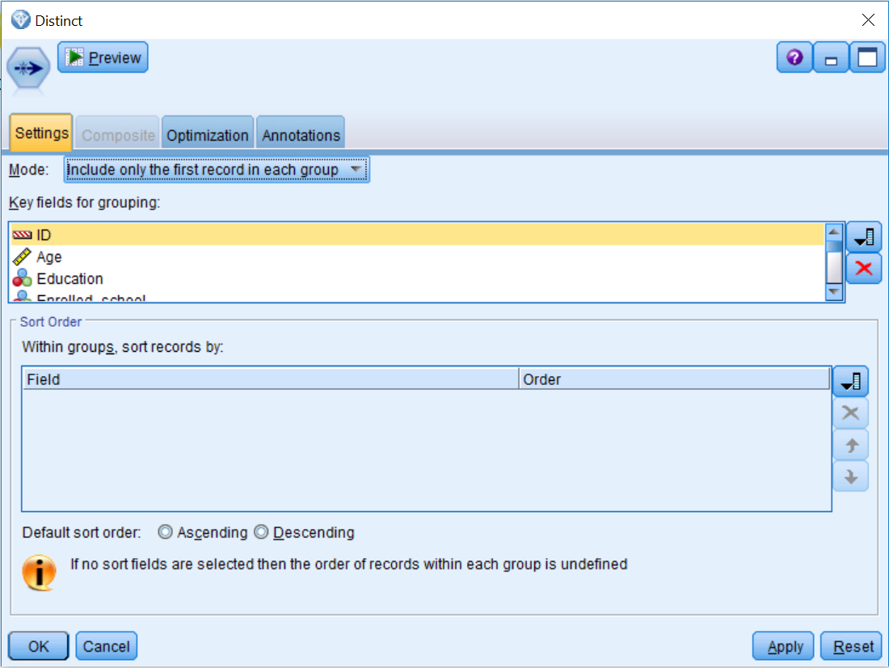

We will now remove the exact duplicate that was found previously in the data file:

1. Click OK.
2. Run the Table node.

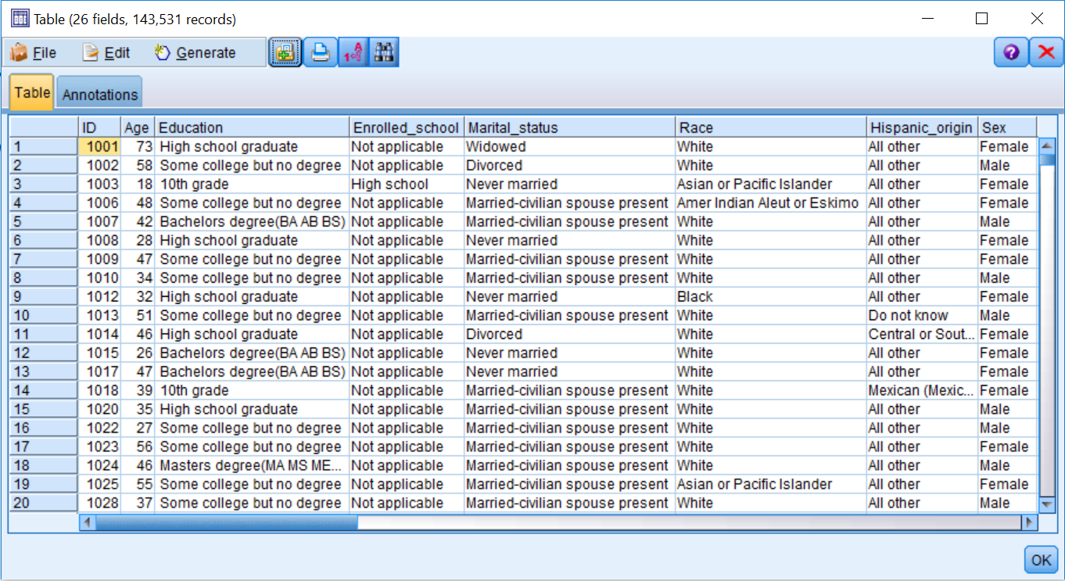

Notice that we have one fewer record in the data file since we have now removed the duplicate case.

**Reclassifying categorical values**

In the previous chapter, we used the Data Audit node to investigate the data file. The most critical problem that was found was that children were included in the dataset; the Select node was used to fix this issue. However, the Data Audit node also revealed additional irregularities within the data. For example, the Education field had too many categories, several of which had very low counts. In addition, the Vet_benefits field, which is a categorical variable, was coded with numeric values, so adding labels made interpretation easier.

Also, the Household_summary field had a misspelled version of a category that was creating an additional unnecessary category. The birth country fields needed to be transformed, given the low counts on most of the categories. We use the Reclassify node to fix all these problems.

The Reclassify node allows you to reclassify or recode the data values for categorical fields. For example, let's say that customers reported satisfaction ratings on a ten-point scale. However, after inspecting the distribution of this field, you realized that if the ratings were reclassified into a three-point (negative, neutral, or positive) scale, that would be more useful for prediction. This is exactly the function the Reclassify node performs. The reclassified values can replace the original values for a field, although a safer approach is to create a new field, thus retaining the original field as well:

1. Place a Reclassify node from the Field Ops palette onto the canvas.
2. Connect the Distinct node to the Reclassify node.
3. Edit the Reclassify node.

The first decision you need to make when using a Reclassify node is to determine what mode you want to use. The Single mode option is used to calculate a single new field (this is the most common use). The Multiple mode option is used to calculate multiple new fields where the same operations are applied to those fields. The new reclassified values will be placed into a New field or an Existing field.

Within the **Reclassify values** section:

* The Get button will populate the Original value column with values from the upstream Type node or Typestab. Alternatively, you can enter the original values directly.
* The Copy button will copy the values currently in the Original value column into the New value column. This is useful if you want to retain most of the original values, reclassifying only a few values.
* The Clear new button will clear all the values from the New value column (in case of errors).
* The Auto... button will assign a unique integer code to each value in the Original value column. This option is useful for replacing sensitive information (SSNs, names) with alternative identifiers, or reclassifying string values to numeric data.

Finally, you have options to use the Original value or a Default value when a value not specified in the New value column is encountered in the data stream. In this first example, we will reclassify the 17 values for the field Education into a new version of this variable with only five categories:

1. Click the field list button and select Education.
2. Type Education_reclassified in the New field name option.
3. Click the Get button in the Reclassify values section.
4. Type No high school degree in the New value box for the 10th grade, 11th grade, 12th grade no diploma, 1st 2nd 3rd or 4th grade, 5th or 6th grade, 7th and 8th grade, 9th grade, Children, and Less than 1st grade rows.
5. Type High school degree in the New value box for the High school graduate row.
6. Type Some college in the New value box for the Associates degree-academic program, Associates degree-occup/vocational, and Some college but no degree rows.
7. Type Bachelors degree in the New value box for the Bachelors degree (BA AB BS) row.
8. Type Advanced degree in the New value box for the Doctorate degree (PhD EdD), Masters degree (MA MS MEng Med MSW MBA), and Prof school degree (MD DDS DVM LLB JD) rows.

Be careful not to click in the last empty row because this will create another value and cause an error when this node is run.

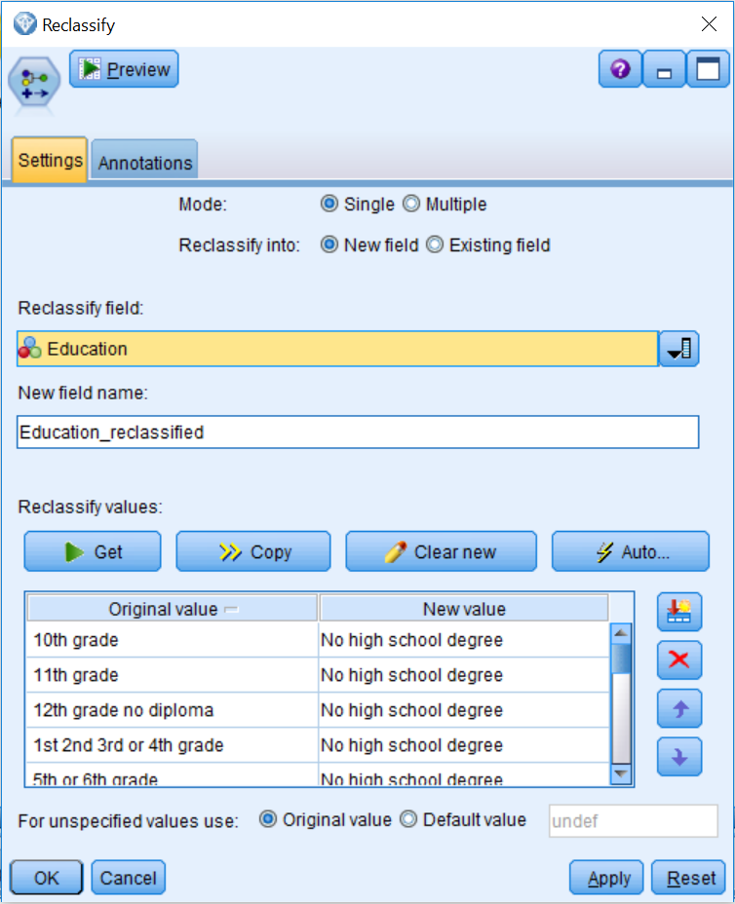

1. Click OK.

Now we have created a new Education field that has five categories instead of the 17 categories that were in the original Education field (to check this command, we will use the Data Audit node later in the chapter).

In this next example, we will replace the original Vet_benefits field with a new version that has labels instead of numeric values:

1. Place a Reclassify node onto the canvas.
2. Connect the Education_reclassified Reclassify node to the new Reclassify node.
3. Edit the new Reclassify node.
4. Click the field list button and select Vet_benefits.
5. Click Existing field in the Reclassify into option.
6. Click the Get button.
7. Type No in the New value box for the 0 row.
8. Type Yes in the New value box for the 1 row.
9. Type Not applicable in the New value box for the 2 row:

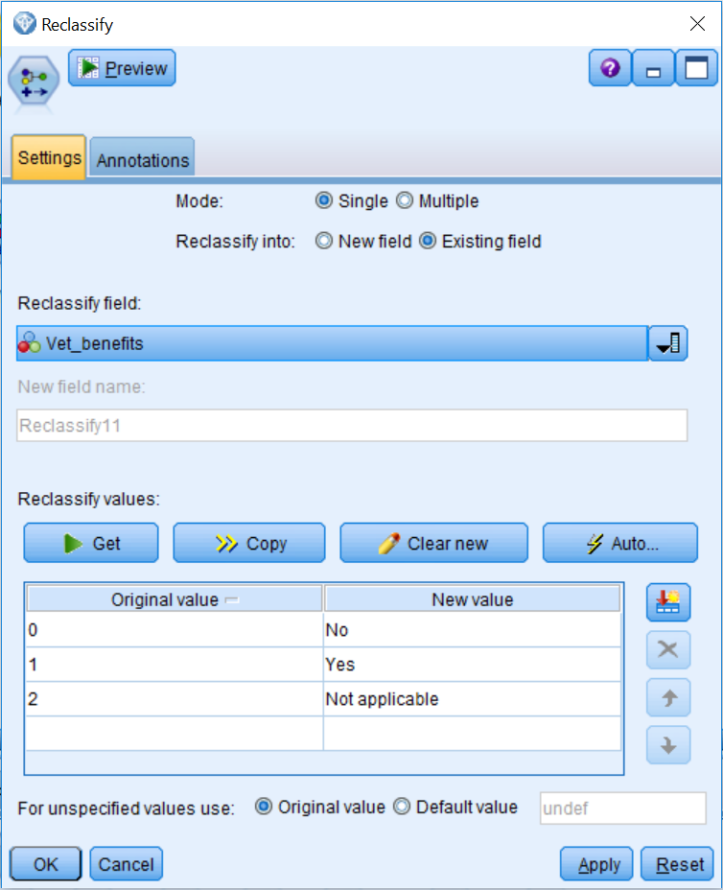

1. Click OK.

We have now replaced the original Vet_benefits field, that had numeric values, with a field that has labels that are easier to understand.

As a last example of the Reclassify node, we will use the Multiple mode option to recode the three birth country fields:

1. Place a Reclassify node onto the canvas.
2. Connect the Vet_benefits Reclassify node to the new Reclassify node.
3. Edit the new Reclassify node.
4. Select the Multiple mode.
5. Click New field in the Reclassify into option.
6. Click the field list button and select Birth_country_father, Birth_country_mother, and Birth_country_self.
7. In the Field name extension box, type _reclassify.
8. Click the Get button.
9. Type United States in the New value box for the United-States row.
10. Type Other in the New value box for all the other countries rows:

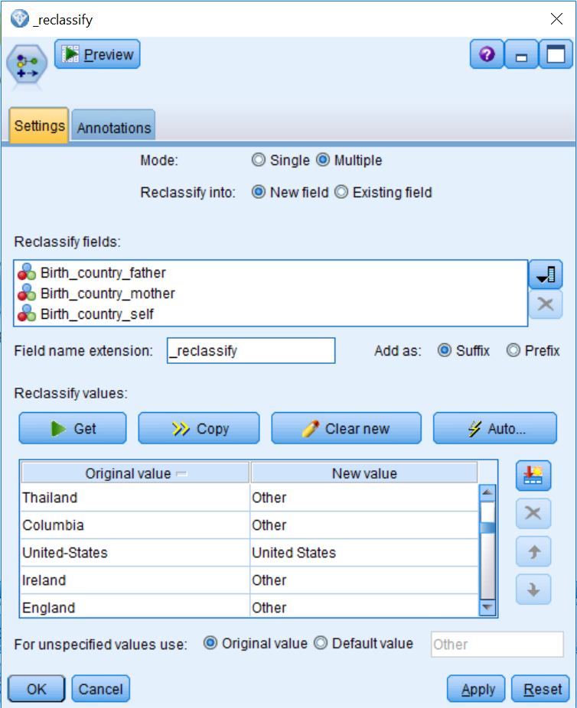

1. Click OK.

Now we have created three new fields that identify whether respondents or their parents were born in the US or in another country.

As a final exercise, it is a good idea to check any modifications you have made to the data. Here we will rerun the **Data Audit** node:

1. Place a Data Audit node onto the canvas.
2. Connect the birth country Reclassify node to the Data Audit node.
3. Run the Data Audit node.

You can see that we now have 29 fields, which is more fields than we had originally. Also, the values for the field Age now have a range from 18 to 90, so we are excluding children from the file:

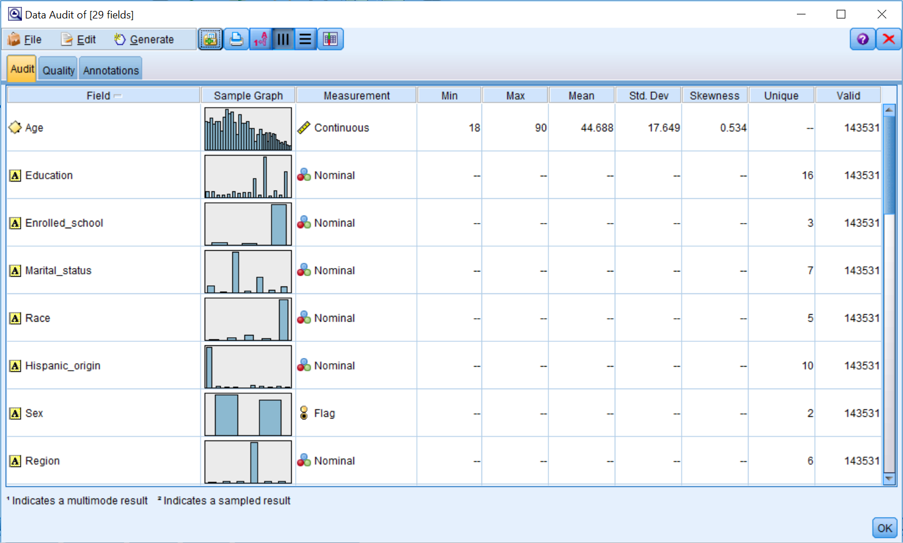

1. Double-click on the thumbnail for the field Education_reclassified.

The distribution of this new field with five categories is much more balanced than the original education field. Typically, this translates into making a variable a better predictor:

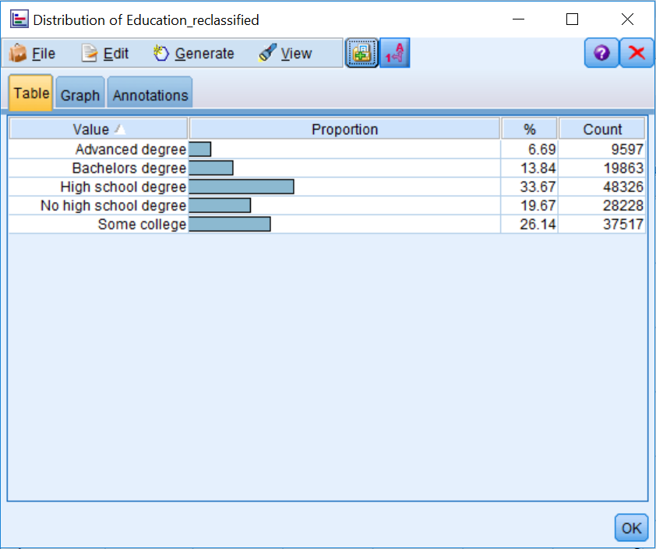

Take some time to investigate the other fields. Notice, for example, that we did not fix the misspelled version of a category for the field Household_summary because this is no longer a problem, since children have been excluded from the data file.

# Summary

This chapter introduced the data preparation phase of data mining. The specific focus of this chapter was on fixing some of the problems that were previously identified in the data during the data understanding phase. You learned how to ensure that you are selecting the appropriate cases for analysis, and you were also exposed to the idea of sorting cases to get a better feel for the data. In addition, you learned how to identify and remove duplicate cases. Finally, you were introduced to the topic of reclassifying categorical values to address various types of issues.

In the next chapter we will expand our data preparation skills so that we can combine various data files. Specifically we will learn to combine data files using both the Merge and Append nodes.